LAB 2 – Tower Officer’s Report – Cedric Hollande & Tyler Chaudhary
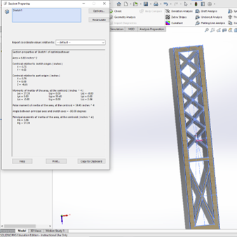

Using SOLIDWORKS’s Section Properties analyzing tool we find the Area of our tower to be 6.83 in^2 which is 44.06 cm^2. Bringing us to a cost of 22.03 MCU for our towers.

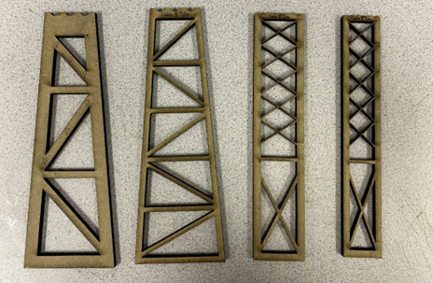
The towers from left to right in the picture below show our process of cutting material to get to a more cost-efficient solution. Although the first solution ensures more safety, it is way too conservative. Indeed, testing manually and using the compressing machine in lab to understand the buckling force we came to the conclusion that for our bridge we needed a narrow tower with a gap in the center supported by “tension cables” (the thin MDF strips). We tried using the machine again Thursday and Friday but it was not available. If we get the chance to test our tower(s) we will reduce the material and maybe change the dimensions of our tower again. We also first thought 1/8 inch was a better solution, or maybe even 2 1/8 inch tower but the ¼ inch version was much more sturdy. Therefore by cutting material out we could minimize the cost with a tower more resistant to the buckling force coming from the cable strings.

