Finn Maniscalco, Sam Stedman, Cedric Hollande
Lab 5–Butane Bottle Rocket Launching
Professor Yim, MEAM 2480
5/3/23
Lab 5 Lab Report
Overall Approach and Competition Strategy:
For this lab, our initial realization was that we would need two four bar linkages working in sync in order to hold the bottle by the output link so that it is balanced on either side. We then realized that we needed to make sure that the output linkage was the innermost linkage so that the bottle holder did not intersect with the other linkages as it rotated. For the same reason, we also needed the fixed linkage to be the outermost linkage to prevent intersection. After realizing it was essentially impossible to satisfy both of these parameters without removing the fixed link, we decided to remove it and instead fix the two points that would attach to this link directly to the stand instead, with the distance between the points remaining the same as the size of the link. Once we removed this link, we began to build the entire assembly before realizing that we also needed a way to hold the bottle in such a way that the bottom was supported when it was upright, but allowed it to launch through the support when it was upside down. We explain the design in the next section of this report, so we will not go in depth into it here. Lastly, we ended up getting rid of our motor adapter in favor of more rigidity in our design, so the linkage would have to be hand cranked.
Our competition strategy, given the flaws we mention in the bottle holder design, was to fill the bottle in its loading position, and then grab the rotator link, flip it quickly, and let go of it so the linkage can fall into its dwell position and let the bottle launch. We filled the bottle roughly halfway (~1 L of water) and then added butane for about 30 seconds from a can sitting in the ice bath. Aside from that, we did not need much of a strategy, since our design allowed for easy, repeatable launches at close to our desired angle. Our favorite part of this design was that it didn’t rely on luck or much involvement from the user to release the bottle the correct way.

Four-bar Linkage Design:
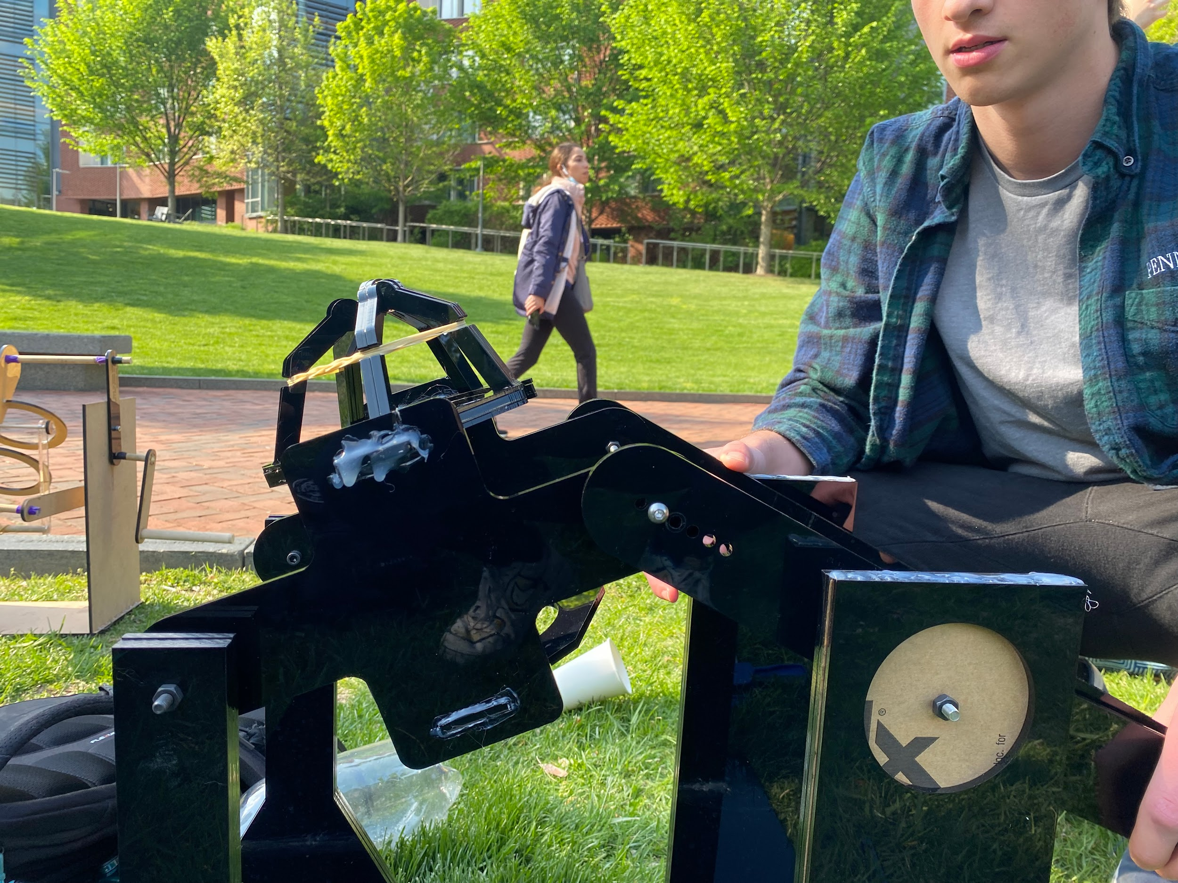
Our four bar linkage was a rocker-crank design, with the crank linkage being driven by the motor, while the rocker link holds the bottle. This way, we get maximum dwell time for the bottle while allowing 360º rotation of the motor. We designed the lengths of the links such that our bottle flips between approximately 90º and 130º based on the adjustability we incorporated into our design via different holes along the length of one of our links. These different settings allowed for different dwell times and corresponding inversion period lengths. Because we want the bottle to flip as quickly as possible and to stall at the launch angle for as long as possible, we chose the 4th setting (out of 6 total). This allowed for us to achieve both a decently quick inversion period as well as having long enough of a dwell time for our bottle to launch. We chose this setting via experiments we performed as described below.
For our dwell time, because we used the same four bar linkage design as Cedric’s Lab 3 group, we can use the same dwell time analysis as follows:
“The dwell time is calculated by finding the driving link to bottle link angular velocity ratio for within 5° of the dwell bottom. Due to the sensitive nature of this design, the small angle approximation would be inappropriate. Instead, the angle measurements were taken from geometry calculations that will be discussed in section IV.” The aforementioned angles from the geometry calculations are as follows:
Driving Angle (º) | Bottle Angle(º)
174.2 | 168.4
193.7 | 173.4
230.3 | 168.4
“We thus find that the driving angle rotates through 56.1° while the launch angle stays within a 5° window. The dwell time can thus be calculated as the time it would take the motor to rotate 56.1°. Thus, the dwell time can be calculated by dividing 56.1 by angular velocity:
T = 56.1/w
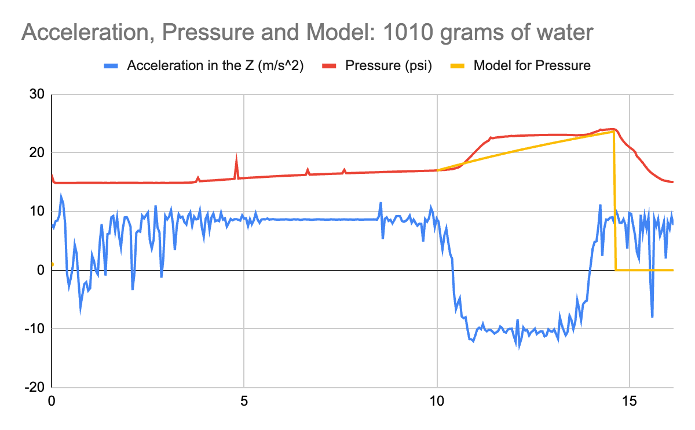
where w is angular velocity in °/second.” Our angular velocity can be controlled by the motor. To understand our limits for this, we must look at the motor specs. From the given datasheet, we see that the maximum angular velocity is 628 rad/s. This is equivalent to about 35982 deg/s. This is obviously far too high and likely impossible to achieve for the first rotation due to the low torque output of the motor. To find the necessary dwell time, we can use the known formula for thrust (F=2PA) as well as the pressure data collected in lab 4 to find the total time we need for the thrust to be greater than the weight of the bottle. In our launch, we filled about 50% of the bottle with water. This corresponds to about 1kg of mass which means around 9.81N = 2.25lbf of force is needed to start launching the bottle. Thus, from our force equation, we have 2.25lbf=2P*(pi*(0.5in)^2). Solving this out, we get that our change in pressure before the bottle launches is 1.43 psi. Looking at the graph to the left for pressure change for 1kg of water, we can see that the data gives an approximate 1.4 psi change starting from the point the bottle closes (when the pressure begins to rise) and ends about 0.12s later. Thus, we just need our dwell time to be greater than 0.12s (looking at the actual data for this plot). Plugging this into our dwell time equation above, we get that we must rotate the motor at a maximum of 56.1deg/0.12s=467.5 deg/s. This makes sense because for every rotation the crank makes, the rocker (to which the bottle is attached) will go from loading state to launching state and back. Thus, since we want the dwell time to be at least 0.12s, meaning the maximum motor rotation speed must be 467.5 deg/s. Any value lower than this will produce enough of a dwell time for the bottle to be launched, but we also want the inversion period to be as quick as possible, so we want to pick an angular acceleration relatively close to 467.5 deg/s.
After considering a couple ideas for the bottle holder, we came up with a design akin to a claw machine arcade game, in which the bottle would sit in a claw with each finger of the claw slotting into the five indents on the bottom of the bottle. We used rubber bands to tension the claw so that it could hold the weight of the bottle but would open up when there was enough thrust to overcome the tension in the rubber bands. This ended up being a really reliable design and it gave us a predictable launch nearly every time.
We realized this design had three flaws, but none of them ended up being consequential in competition: 1) The tension of the claw reduced the amount of usable thrust resulting in a slightly shorter launch distance, but our group still came in second for combined launch distance (ignoring the group that. 2) The claw fingers could open asymmetrically causing the bottle to fly in an unpredictable direction, but this only happened once because we didn’t put in enough butane so it didn’t launch fast enough. 3) The force required to exit the claw was less than the force needed to rotate the system, so the bottle launching could cause the linkage to rotate out of the desired launch angle. This seemed like a fatal flaw before testing, but when we got to testing we realized that the direction of force was nearly perpendicular to the angular path that the linkage follows, so it ended up not spinning the linkage by luck. Also, our dwell time was long enough that by the time the bottle got through the claw, the system wouldn’t have rotated enough to cause a substantial effect on the angle.

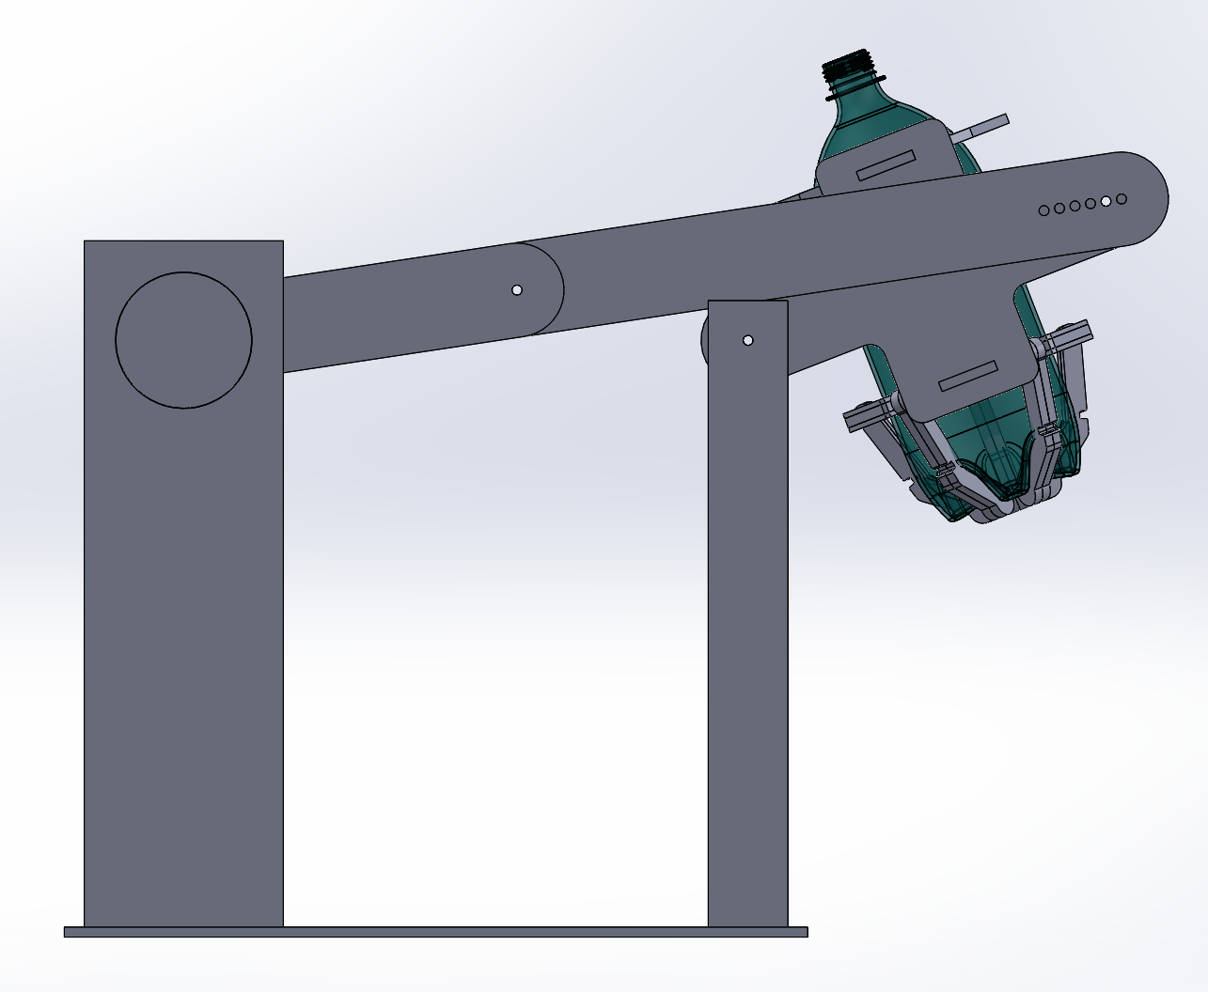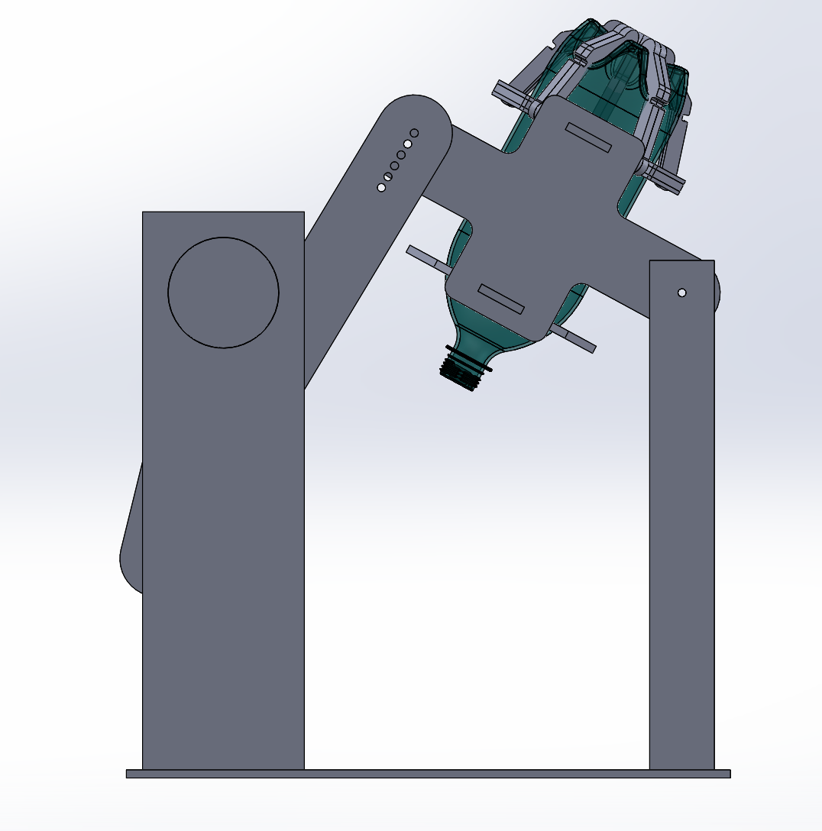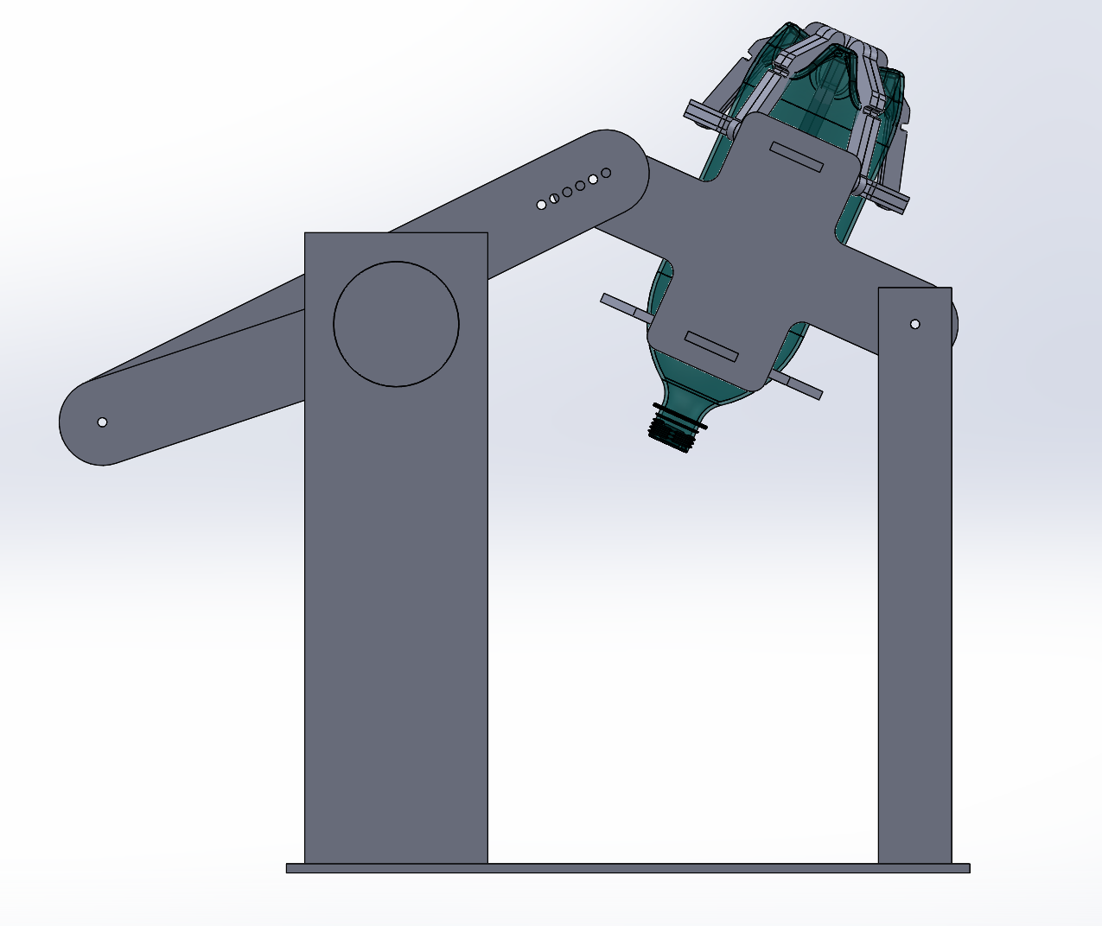
Bottle Load Bottle launch Dwell end
Rotating clockwise

Trajectory Model Description:
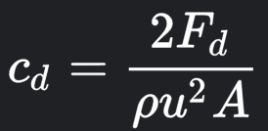
Thrust_time = 0.4s (thrusting during 24 frames in a 60 fps video), Thrust = 65N, Gravity = 9.81N, Drag_coeff = 0.345 (estimated), Drag_Force = Drag coeff * rho * A / 2 = (0.345 * 1.225 kg/m^3 * pi * (0.06m)^2) / 2 = 0.00208, m_bottle = 0.042 kg, m_water = 1 kg, m_butane = 0.03 kg
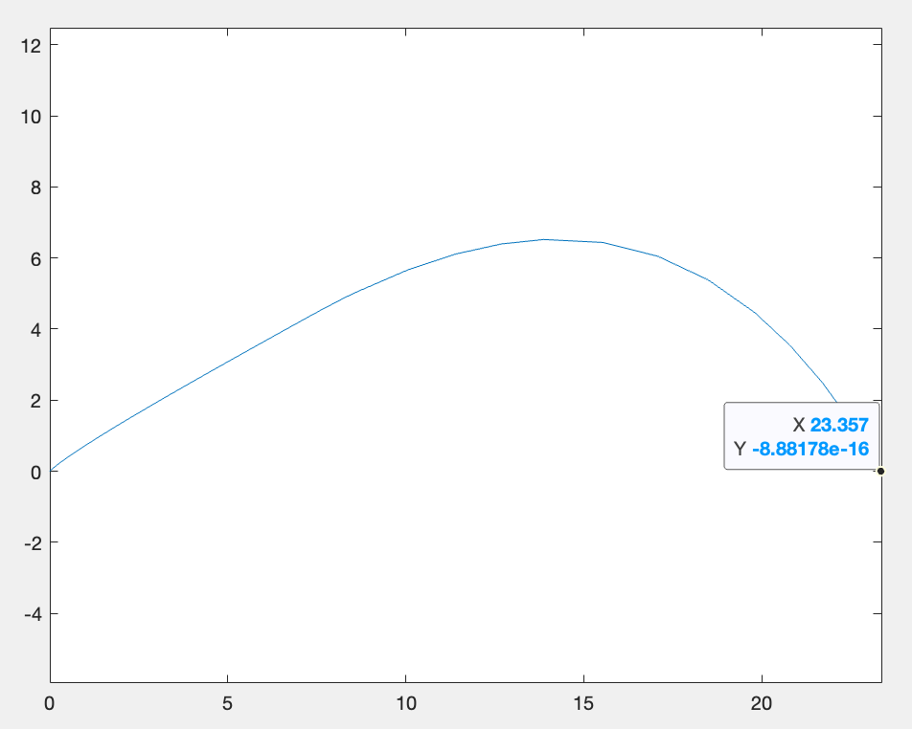
This model takes in total thrust time, a calculated thrust, a drag coefficient, the mass of the bottle, the mass of the water, and the mass of the butane. The variable drag_coe is the bottle’s drag coefficient multiplied by the density of air multiplied by the cross-sectional area of the bottle divided by 2. Essentially, it encapsulates all the terms in the drag force equation other than velocity (which is calculated and handled within the model itself). Our drag coefficient was 0.345, which was found online from various empirical datasets. Our thrust time was calculated by looking at the number of frames that the bottle was ejecting water for during our test launches. The model uses differential equations of motion, accounting for decreasing mass over time, to find the trajectory of the bottle. It treats the launch as two separate phases; a thrust phase and a free fall phase. The thrust phase lasts for however long your input thrust time is, and your free fall phase is the entirety of the rest of the launch until the bottle hits the ground. This model was created by Cody Hopkins, Fiona McLaughlin, and Oren Minsk, but was adapted and calibrated by us to fit our group’s launch specifications. We validated this model by running a few real-life tests on how far the bottle launched with our ideal case (the water and butane mass we were planning on launching with). Unfortunately, we didn’t test other combinations of masses, but we did check what launch angle was best. We found on launch day that, for the 6th angle adjustability setting (~50° launch angle), the bottle went 76 feet. The model predicted for these inputs that the bottle would go 23.36 meters or about 77 feet, leaving us with an error of about 1.3%. To account for any given wall height or distance, we would adjust the input angle and water mass until we got a trajectory that would clear the wall. We would then adjust the amount of butane we would put in to keep our ratio the same so that it could output maximum thrust. See below for a more detailed description of how we found this maximum thrust.

Experiments Run:
Four bar linkage length configuration tests
In these experiments, we changed the lengths of the four-bar linkage to investigate their impact on the distance the bottle traveled when flipped. By changing the lengths of the bars, we can change the motion of the linkage and the timings. We laser cut several different prototypes until we were happy with the dwell and inversion period (time it took to flip the bottle). The first prototype had the following lengths: base (360 mm), rotator (215 mm), connector (335 mm), bottle link (245 mm). With this first prototype we managed to get the bottle link to have a rotating range a little smaller than 180 degrees which was ideal. With the following prototype, we wanted to see if we could increase the dwell time even more and decrease the inversion period. We then lasercut a longer connector link which had 6 settings, one every 10mm, from 245 to 295 mm. Playing around experimentally, our preferred setting for the best angle and total distance traveled by the bottle was the 4th setting.
Water temperature tests
In this experiment, we tested the effect of hot water and medium temperature water on the distance the bottle traveled. We chose this experiment because the temperature of the water affects the pressure inside the bottle, which in turn affects the distance it travels. The hotter the water was the better the difference in distance traveled seemed to be (around 5 feet). When dispensing butane into the bottle, it quickly starts evaporating into gas and expands in volume. When flipping the bottle the liquid butane is trapped by the water leading to an increase in pressure. This creates thrust which propels the water out and the bottle forward. Hence, it makes sense that the hotter water would lead to a greater travel distance. This is because when water is hotter, the cold liquid butane will evaporate faster and lead to greater pressure and thrust.
Water quantity tests
We tested launches with bottles filled with 25%, 33%, 50%, 60%, 70% water, releasing butane into it for 15 seconds (around 30g of butane). The configuration that best suited our machine was filling the bottle with 50% water. If we fill the bottle too much, we encounter several problems: we will lose butane while flipping the bottle, the bottle will be heavier and the water will stay in the bottle for longer which may lead to it flying uncontrollably in the wrong direction. If the bottle has barely any water, flipping the bottle will not lead to any major pressure difference which won’t give us sufficient thrust. Therefore, by testing each water volume 3 times, we found that the 50% water-filled bottle worked best with our machine.
Butane temperature tests
In this experiment, we analyzed the effect of cooling the butane can for different durations on the distance the bottle traveled. We chose to do this experiment because cooling the can may affect the pressure of the gas inside it, which can in turn affect the distance the bottle travels. We found from our tests that cooling the bottle for 10 minutes gave us very slightly better results (around 5 feet more). This makes sense since the cooler the butane is, the less butane we will lose to evaporation while dispensing it in the water bottle.
Butane/Water Ratio Choice:
We found our butane/water ratio with the goal of outputting the maximum possible thrust. We found this thrust from the testing data from lab 4, as well as our tests for this lab in particular. For the above plot of acceleration and pressure for 1010 grams of water, we get a maximum pressure change of approximately 9.3 psi. Finding the max thrust from this pressure change gives us about 14.6lbf = 65N. This was also the maximum output thrust from any combination of water mass and butane mass that we tested. Through these tests, we found that a ratio of approximately 0.03 kg butane to 1 kg water was optimal to achieve this target thrust. Through the trajectory model, we can adjust the launch angle of our 4 bar linkage to account for a wall of any height or of any distance away. We can also adjust the input thrust to be the max thrust we calculated from our testing (65N). We calibrated the rest of the trajectory model as described above to fit our bottle’s specific characteristics for our ideal launch. Given some wall height and distance, we can use the trajectory model to check that our input angle and water mass (with which we would adjust the butane mass to achieve the above thrust) will clear the given wall dimensions.

Performance Discussion:
The system performed as expected on the test day. For the first test we filled the bottle with 50% water and 15 seconds of released butane (around 30g of butane). We reached 76 feet travel distance and this was our best of the two experiments. For the second test, we decided to have more water (70% full) to try and get a longer launch; however, it went to 49 feet. This could be due to environmental factors, but it probably is due to the fact that the added water resulted in lower acceleration. Overall, the four-bar linkage was very reliable and consistently worked as expected with a fast rotation period (flip time) and a sufficient dwell time. The best way to get far better results would likely be to improve the aerodynamics of the bottle. This could include adding fins to the bottle which would allow for stability of our bottle throughout flight. We could also design and 3D print a nozzle to accelerate the water outwards even more, resulting in an even greater thrust, thereby propelling our bottle even further.

Final run video:
https://drive.google.com/file/d/1lfKdWfvDFfuhSnKPuR6du1su6Q4h3IPp/view?usp=sharing

Appendix
Trajectory Model Code:
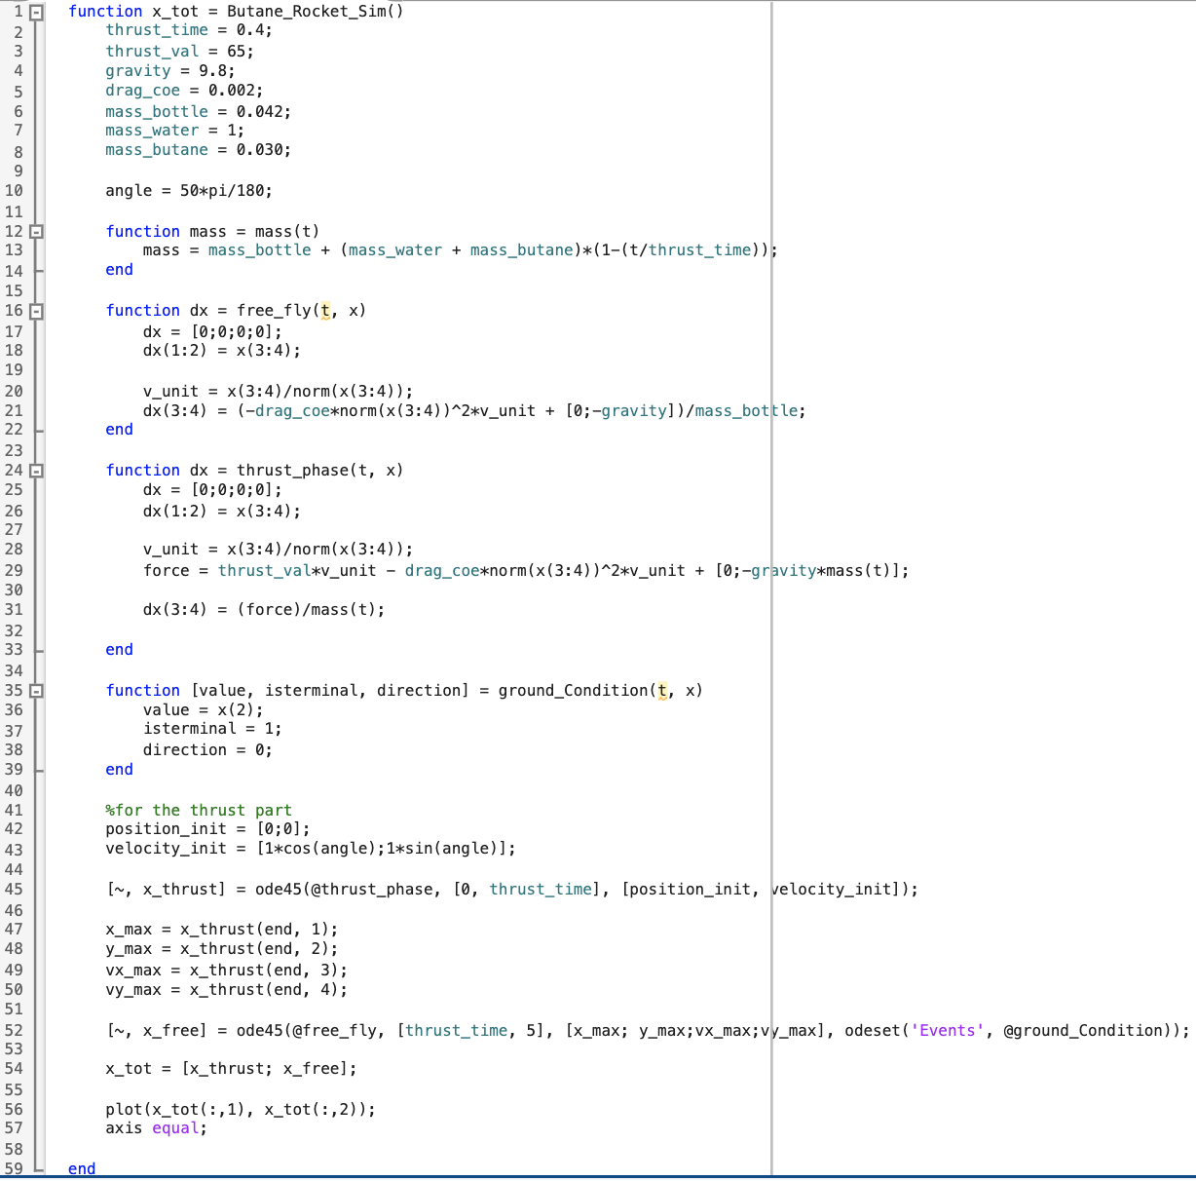
Credit: Cody Hopkins, Fiona McLaughlin, Oren Minsk

