Lab1: Final Writeup
Cedric Hollande, Cody Hopkins, Ethan Hu

Objective
Our journey in this project embarks upon innovating a bungee cord design utilizing string and rubber bands. The primary goal centers around achieving the optimal free-fall distance without ground contact and without exceeding the predetermined maximum deceleration. This comprehensive update outlines the substantial advancements we’ve accomplished in conceptualizing our model, a culmination of invaluable insights gathered from the characterization of rubber bands and acceleration analysis.

Activity 1 - Comprehensive Bands Characterization
In our pursuit to understand the nuances of rubber bands, we employed the MTS machine for exhaustive testing. The primary focus was to decipher the intricate stress-strain behavior and comprehend the bands' elastic properties, which are pivotal in formulating our bungee cord in tandem with strings.
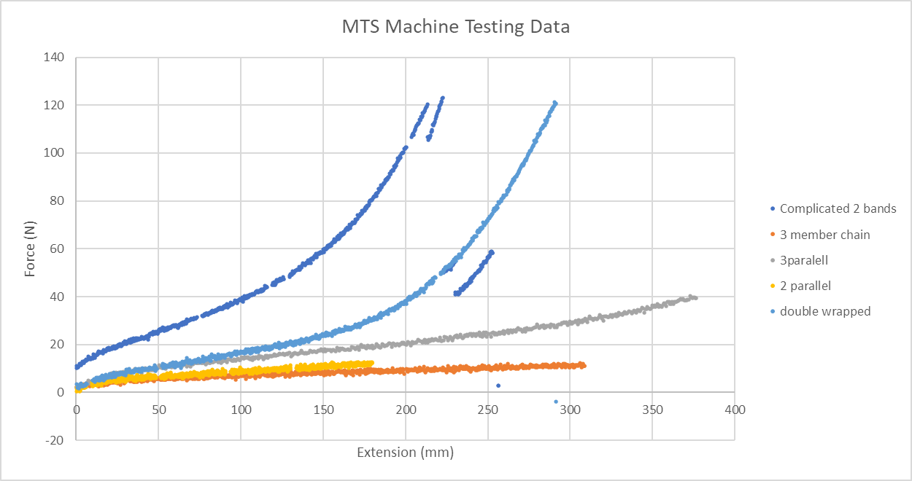
Fig. 1. MTS Testing Data
The chart above (fig. 1) shows the tests our group performed. Several different methods of chaining bands were tested and compared. For the chaining method we selected (see image below). Our in-depth analysis has provided us with solid findings. By using a polynomial of degree 3 to regress the double-wrapped chain, we are able to get an $R^{2}$ value of 0.98 and looking at our graphs we have no random or extraneous data. Therefore we are very confident that these results are statistically valid. The equation is as follows : $F=38.5 + 0.462x + 0.00342x^{2} + 0.0000103x^{3}$ .
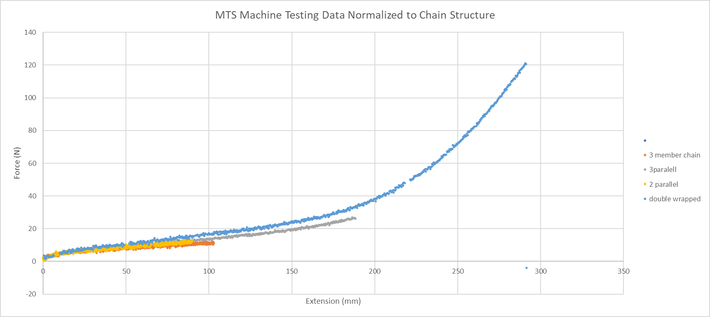
Fig. 2. MTS Testing Data (normalized)
In the graph above (fig. 2), each of the different tests were normalized to determine the equivalent function if it were in the shape of the chain. In other words, a linear transformation was applied to each graph to see if the fundamental properties of the bands were identical between tests. Close results were observed, as expected.
In the above equation, x is the extension in mm and F is the force in N. The 95% confidence interval can be determined using the standard error calculation (with the equation as shown below). This standard error can be used to offset the prediction equation at any given point, and safety factors corresponding to this offset will be used to ensure that the jumper does not exceed maximum forces or hit the ground. This confidence interval was incorporated with a 9% safety factor on the drop distance.
${s.e. = s}_{yx}\sqrt{1+\frac{1}{n}+\frac{(x_{o}-\underline{x})^{2}}{SS_{x}}}$

Activity 2 Summary - Deciphering Acceleration
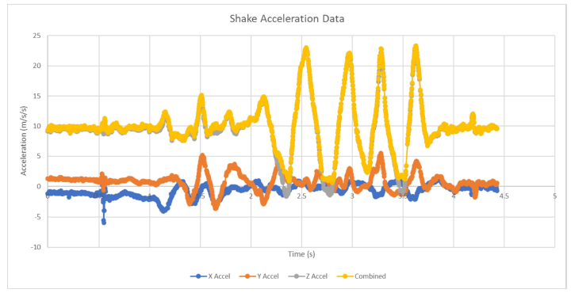
Fig.3. Measured acceleration during shake
The chart above (fig. 3) shows acceleration data measured from shaking the device. The accelerometers have proved reliable and accurate in their measurements.
Instrumentation and Methodology: Our objective was precise in this phase - to determine the acceleration of a descending mass with paramount accuracy and consistency. Utilizing Arduino Uno coupled with pertinent sensors allowed us to derive reliable measurements. The accelerometer readings were recorded to an SD card attached to an Arduino and shield, which were then loaded into Excel where the results are graphed.

Activity 3 - Model Development
The model physics development has been completed. Further analysis of the data shows that it will be difficult and inconsistent to intentionally cause a band to break without exceeding the maximum g-forces. Hence, the model will only consider the use of one band.
In-depth Model Approach: As opposed to using hand calculations to solve for a closed form solution, a modeling approach is used.
The model uses the non-linear properties of the tested elastic bands that are expressed as regressed equations. This information is used in the band_force function, which returns the force of tension on the band given its stretched length. Below its rest length, the force is 0. Beyond its max length, the band breaks and the force is also 0.
Then, the bands are assembled in a parallel-series combination with string to create a chain. A “chain” consists of bands in parallel and series, along with a length of string at the end. To combine bands into chains, we can simply apply a linear transformation: stretching the regression curve horizontally for bands in series and stretching the curve vertically for bands in parallel. We can simply multiply the extension distance by the number of bands in series and the force by the number of bands in parallel.
The weight is written as an object with position, velocity, and acceleration. This weight also has a move function which uses the information from the band to calculate the new position of the weight per time-step. The only two forces on the object are the force of gravity and the force from the band. It was determined that the effects of air resistance are negligible (as well as difficult to quantify), so they are neglected. Each time step, this new position is recorded and stored to a list to be later graphed.
Finally, an optimizer function was written (last cell). This function takes in the parameters that we will receive on the day of the competition. It will iterate through all reasonable parallel counts, series counts, and string length, running the simulation for each drop setup. The drops are then verified that they do not exceed the maximum g-forces or fall too far. The acceptable runs are then added to a list of dictionaries which is then sorted by the furthest fall-length. The best 15 runs are output, and one of them will be manually selected for the test.
The model was designed such that on the day of competition we can input all of the variables given to us and it will give us the ideal lengths of string and rubber band in order to stay within the limits given. Sample outputs in the Parameters and Setup section below (fig. 6/7).
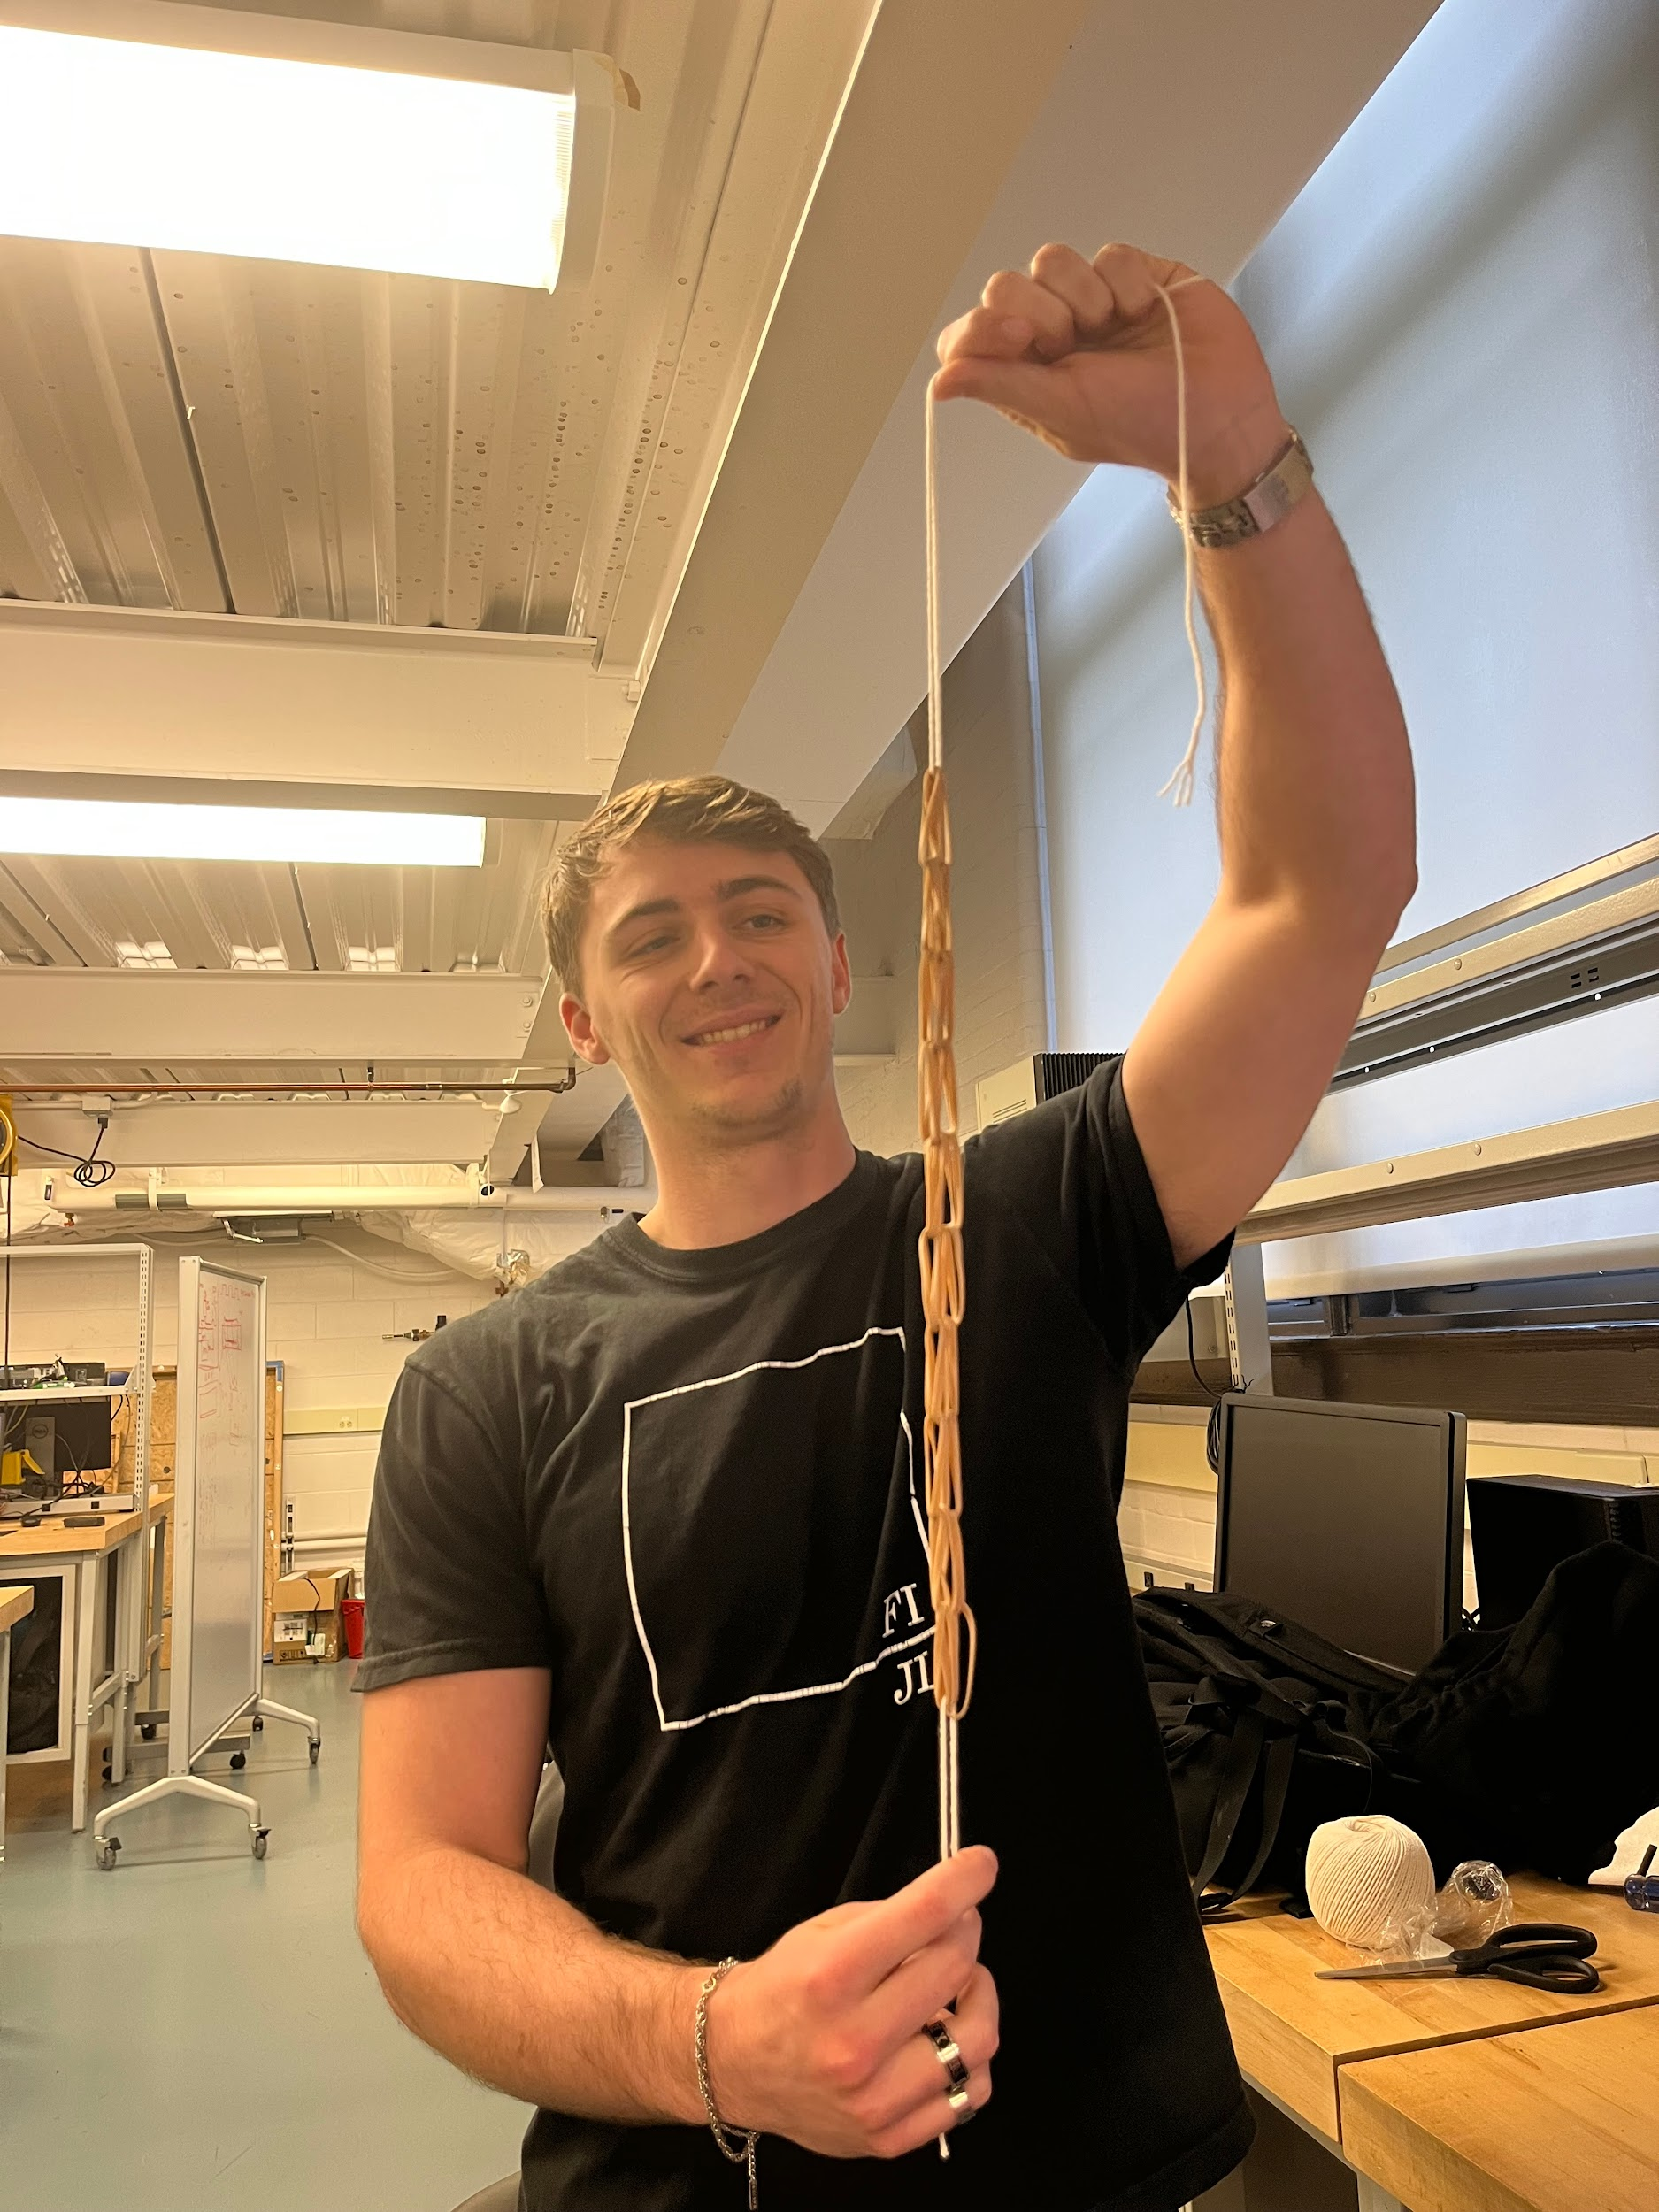
Colab found below: https://colab.research.google.com/drive/1cvIm_hTGQ_8bcVRXq0Y1i-YNtfHydxli?usp=sharing

Attachments
The end of the cord is just a loop of rubber band therefore it will easily attach to the carabiner which will, in turn, connect to the jumper and arduino (fig. 4).The weight, arduino, and battery were all in turn, placed in a bag through which holes were poked to thread the string. Fig. 4. Chain design

Parameters and Setup
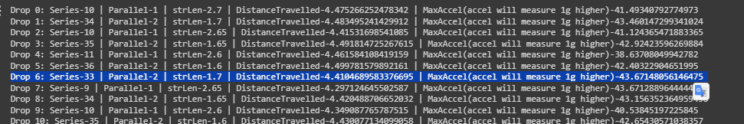
Fig. 5. Optimization Result from colab, best configurations listed. Option 6 Chosen.
Selected configuration: Series: 33, Parallel: 2, String length: 1.7m
Freefall drop: 1.7+33*0.04 = 2.24m
Predicted acceleration (max): 43.67m/s/s
Predicted freefall time: 0.76s
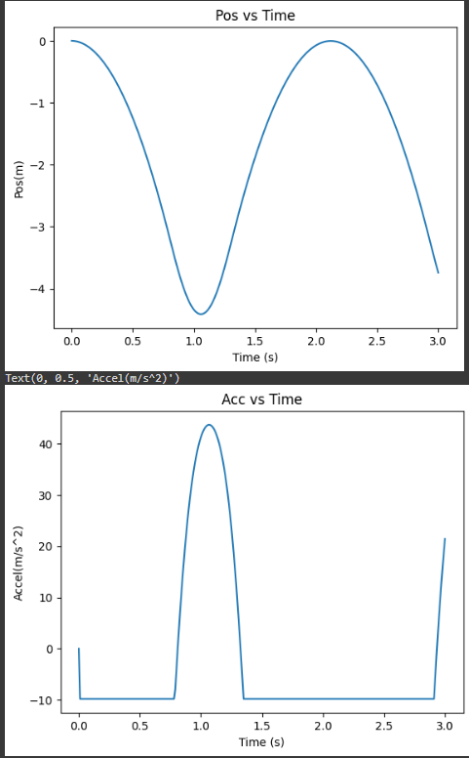
Fig. 6/7. Position vs Time and Acceleration vs Time of drop displayed.
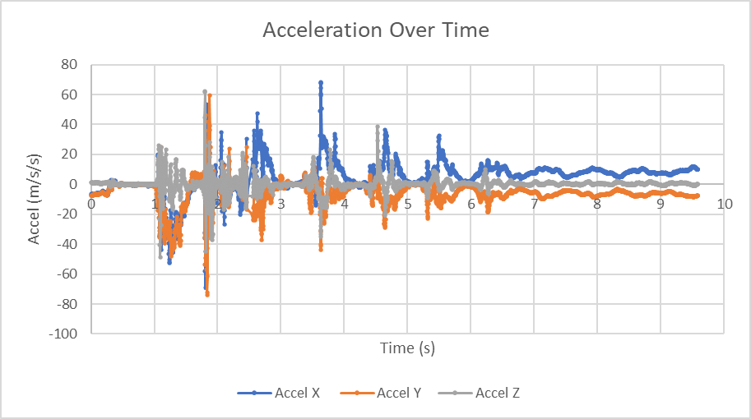
Results

Fig. 8. X,Y,Z component of acceleration over time
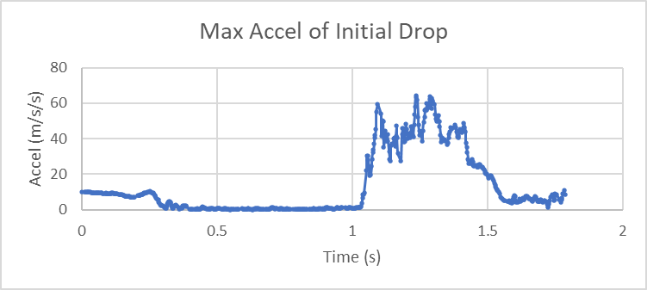
Fig. 9. Combined X,Y,Z acceleration of initial drop.
Measured freefall time: 1.033-0.31 = 0.723s, Measured Max Acceleration: 64.3m/s/s
The predicted freefall of 0.76s and the measured of 0.72s align very closely. The overall shape of the acceleration experienced graph is also similar, though there are spikes that cause the maximum to exceed the predicted. A value of 43.7m/s/s of acceleration, or 53.5m/s/s measured (+1g gravity) was predicted. However, the maximum detected was over 60m/s at 64.3m/s/s. Note that this maximum acceleration is likely due to the bag “whipping” around at the end of the fall and movement of objects within the bag itself. This effect was observed during preliminary experiments as well, and hypothesized that adding the bands to the bag and string to the beam attachment would mitigate the issue. It seems like the effect was reduced slightly, but the resulting acceleration continues to have spikes. The distance to the ground was 18 inches, slightly more than the predicted 14.5 in that was used as a safety factor. It is also worth mentioning that we know the distance to the ground was 18” based off of the video from Dr. Keller however the video we have attached doesn’t show the bottom out distance but it is a video of the same fall. It also seems that the reduced fall distance is evidence that the bands used were slightly tougher than expected. This may also contribute to overshooting the g forces as the force provided by the bands are higher than expected.
Video here: https://youtube.com/shorts/hqQV1Lol8q8?si=bFrejfaPOuiMs6cD

Final Conclusions
Overall we are very pleased with the results of our model. Firstly the rubber band model was both very insightful to the mechanics of how rubber bands work but it was also very useful when creating our final mode. I do believe that our model was not very accurate at large strain values so that caused our model to predict them to be weaker than they actually were when extended very far. Moreover our full model was very successful in that all of our test drops and final drop were relatively accurate to what the model predicted. If we had the opportunity to refine this lab more we would spend more time characterizing the rubber bands in the specific configuration that we used. Also we would make a better jumper setup such that we could mitigate the whipping issue that caused our decelerations to be higher than allowed.

