MEAM 510 - Lab 1

1.1 LED

1.1.1 Choosing an LED and a Resistor
I chose the 160-1128-ND 5mm red LED, LTL-4224. From the datasheet we can see that the LED has a maximum forward voltage V_f = 2.6V and peak forward current I_f = 0.02A. To calculate the smallest value of the resistor that can safely be used with a 5V power supply we use Ohm's Law (V = I * R):
R = (V_supply − V_f) / I_f​
This gives us R_min = (5 - 2.6V) / 0.02A = 120Ω
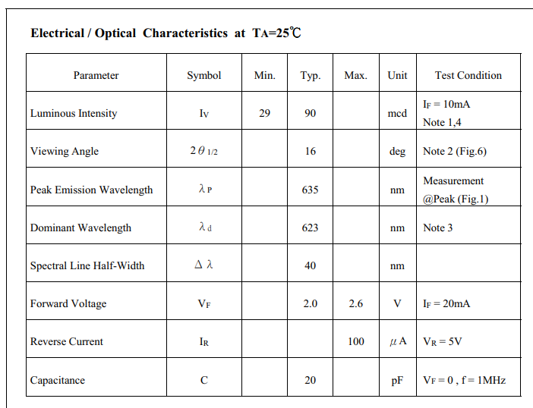

1.1.2 Hooking up the LED
I tried 150Ω, 1kΩ, then 15kΩ, 22kΩ and 33kΩ resistors. I could see a light until 33kΩ, however I would say it is most practical to go up to 15kΩ, after that point the LED light is barely visible.
I_f​ = (V_supply − V_f) / R
I_f = (5 - 2.6V) / 33,000Ω = 7.27e-2mA

1.1.3 LEDs in Parallel
I chose the 3mm blue LED LTL1CHTBK4 with forward voltage 3.8V and forward current 20mA and the 3MM YELLOW LED, LTL-1CHYE with forward voltage 2.6V and forward current 20mA. The voltage at point A is 0.03V, and the voltage of both resistors is 2V.
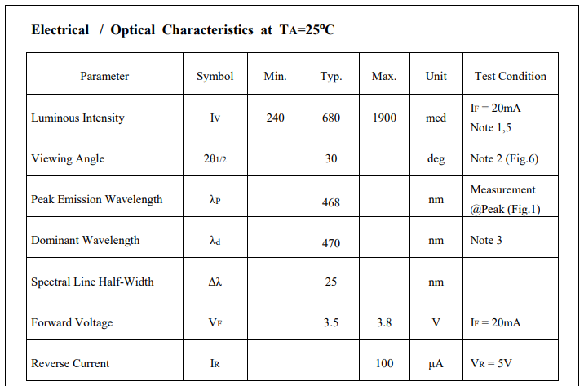

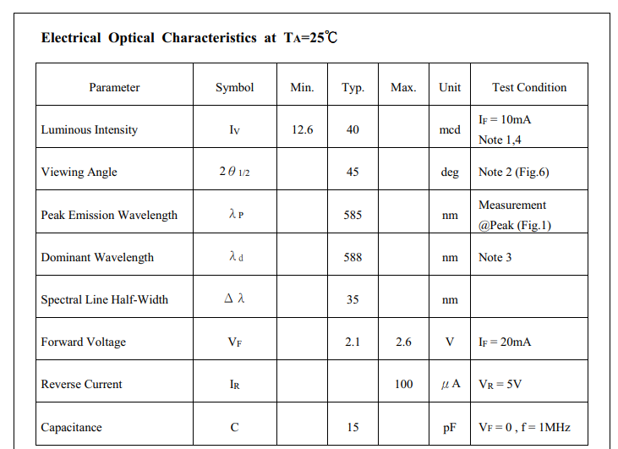The LED with the lower forward voltage (yellow) consumes more current which explains why it is brighter (the blue LED is barely on).

1.1.4 LEDs in Series
The blue LED shines (seemingly) brighter (since they are both at the same current). The voltage at point A is 0.03V, the voltage of the yellow LED is 1.93V, and the voltage of the blue LED is 3.04V.

1.1.5 LED Light Source Design
https://www.digikey.com/en/products/detail/american-bright-optoelectronics-corporation/AB-10TA10-80K/9959338
- Brightness: With a flux of 100lm at 25°C, this LED is sufficiently bright for a desk lamp that aims to illuminate a wide area. The cool white light with a CCT of 8000K is ideal for tasks that require high visibility and focus.
- Voltage and Power: The LED operates at a typical forward voltage of 12V and has a power rating of 1.0W, making it energy-efficient while still providing ample brightness.
- Size: The LED has a diameter of 0.394" and a maximum seated height of 1.024", making it compact enough to fit into a sleek and modern desk lamp design.
- Cost-Effectiveness: The unit price of $8.94 is reasonable for the features it offers.
Therefore, the AB-10TA10-80K LED is the LED I would choose for a desk lamp project which requires a balance of brightness, energy efficiency, compact size, and cost-effectiveness.

1.2 ItsyBitsy INTRODUCTION

1.2.1 What registers are we changing and why?
Registers modified include the Data Direction Register B (DDRB) and the Port B Data Register (PORTB). I configured the DDRB register to set PB6 as an output. PORTB is toggled for LED manipulation. These registers are fundamental for GPIO pin control on the Atmega32u4.

1.2.2 Attach an LED + diagram
I used the same set up (with corresponding Red LED and 470 Ohm resistor).
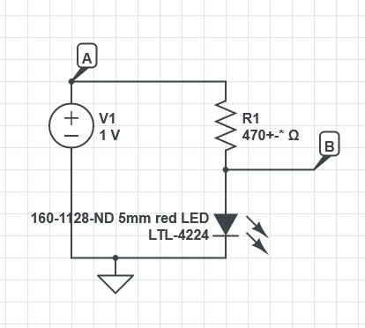

1.2.3 Using the _delay_ms() routine
/* Name: main.c
* Author: <Cedric Hollande>
*/

#include "MEAM_general.h" // includes the resources included in the MEAM_general.h file

int main(void)
{
_clockdivide(8); //set the clock speed to 62.5kHz by dividing 16 MHz by 64
set_led(ON); // turn on the on board LED
_delay_ms(1000); // wait 1000 ms when at 16 MHz
set(DDRB, 6); // Set PB6 as an output

for(;;){
set_led(TOGGLE); // switch the led state
_delay_ms(1000); // wait for 1000 ms

clear(PORTB, 6); // Toggle PB6 as an output
}
return 0; // never reached
}

1.2.4 Create a variable for the duty cycle
/* Name: main.c
* Author: Cedric Hollande
* Copyright: <insert your copyright message here>
* License: <insert your license reference here>
*/

#include "MEAM_general.h" // includes the resources included in the MEAM_general.h file

int main(void)
{
int dutyCycle = 50; // 50% duty cycle
int delayTimeHigh = 10 * dutyCycle; // LED ON duration
int delayTimeLow = 1000 - delayTimeHigh; // LED OFF duration

_clockdivide(8); // Set the clock speed to 62.5kHz by dividing 16 MHz by 64
set_led(ON); // Turn on the onboard LED
_delay_ms(1000); // Wait 1000 ms

set(DDRB, 6); // Set PB6 as an output

for(;;) {
// Main loop
set_led(TOGGLE); // Switch the onboard led state

// Handle PB6 based on dutyCycle
if (dutyCycle > 0) {
set(PORTB, 6);; // LED ON
_delay_ms(delayTimeHigh);
}
if (dutyCycle < 100) {
clear(PORTB, 6); // LED OFF
_delay_ms(delayTimeLow);
}
}
return 0; // never reached
}

1.3.1 Blinking an LED at 20Hz Using a Timer
To achieve a 20Hz frequency, the timer must overflow or match a specific count value every 50ms (1/20Hz = 0.05 seconds). 16MHz clock, divide by 64 activating CS30 and CS31: 250,000, 50ms corresponds to (250,000 / 20) / 2 = 6250 (we divide by 2 again since we want to turn ON and OFF in one clock cycle)

#include "MEAM_general.h"
#define COMPAREVALUE 6250 // The maximum count value that the timer should reach (divide to take into account ON/OFF)

int main(void) {

_clockdivide(6); // Set the clock divider to 0, keeping the system clock at 16 MHz
set_led(ON); // Turn on the onboard LED
set(DDRB, 6); // Set PB6 as an output

TCCR3B = 0x01; // Turn on Timer 3 (no prescale)

for (;;) { // Infinite loop
if (TCNT3 > COMPAREVALUE) { // Check if the Timer 3 count (TCNT3) is greater than the set maximum value (COMPAREVALUE)
toggle(PORTB, 6); // Toggle the state of PB6, switching the LED between ON and OFF
TCNT3 = 0; // Reset the Timer 3 count to 0
}
}
return 0;
}

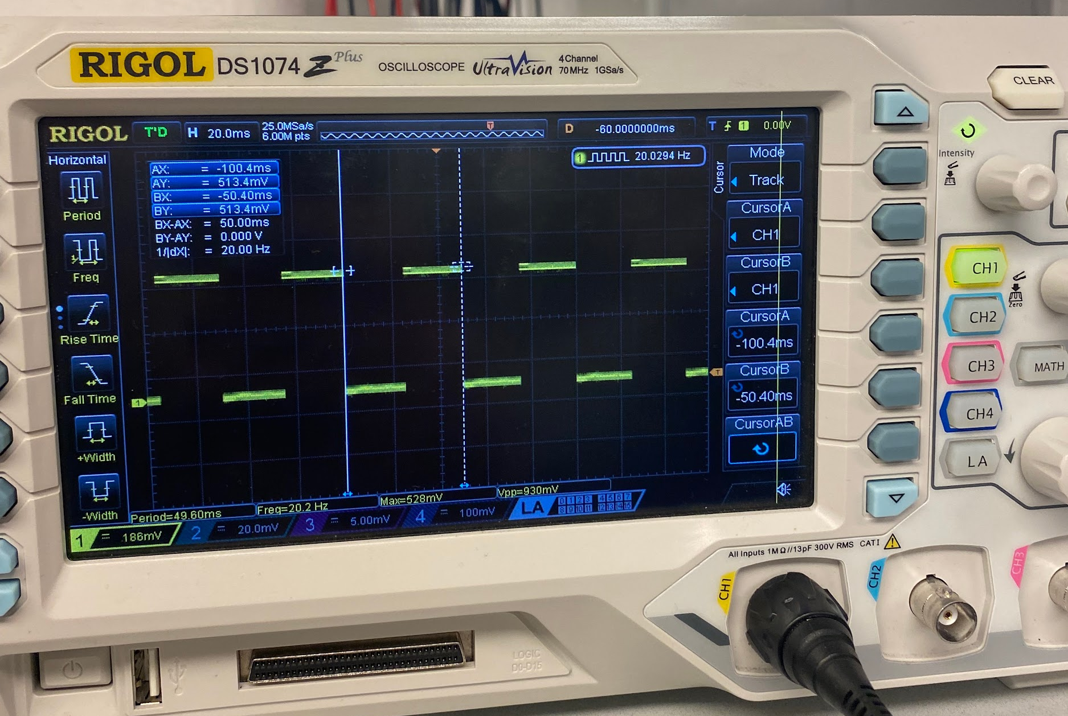

1.3.2 Adjusting the System Clock Pre-scaler
Same result:
#include "MEAM_general.h"
#define COMPAREVALUE 6250 // The maximum count value that the timer should reach (divide to take into account ON/OFF)

int main(void) {
set(DDRB, 6); // Set PB6 as an output

TCCR3B = 0x01; // Turn on Timer 3 (no prescale)
set(TCCR3B, CS30); // Set the CS30 bit in TCCR3B to 1
set(TCCR3B, CS31); // Set the CS31 bit in TCCR3B to 1
clear(TCCR3B, CS32); // Clear the CS32 bit in TCCR3B to 0; setting CS30 and CS31 provides a prescaler of 64

set_led(ON); // Turn on the onboard LED

for (;;) { // Infinite loop
if (TCNT3 > COMPAREVALUE) { // Check if Timer 3 count (TCNT3) is greater than the COMPAREVALUE
toggle(PORTB, 6); // Toggle the state of PB6, switching the LED between ON and OFF
TCNT3 = 0; // Reset the Timer 3 count to 0
}
}
return 0;
}

1.3.3 PWM Generation Using Timer Registers

#include "MEAM_general.h"

int main(void) {
set(DDRC, 6); // Initialize PC6 as an output

// Configure Timer 3 for Fast PWM mode (WGM30 and WGM32 bits set)
// (mode 7) UP to 0x03FF (10-bit), PWM mode
set(TCCR3A, WGM30);
set(TCCR3A, WGM31);
set(TCCR3B, WGM32);
clear(TCCR3B, WGM33);

// Enable Clear On Timer Compare match (COM3A1 set, COM3A0 cleared)
set(TCCR3A, COM3A1);
clear(TCCR3A, COM3A0);

// Set no prescaling
set(TCCR3B, CS30);
clear(TCCR3B, CS31);
clear(TCCR3B, CS32);

// Initialize duty cycle variable
uint8_t duty_cycle = 0; // Range is from 0 to 255
uint8_t increment = 1; // Variable to determine whether to increment or decrement the duty cycle

for (;;) {
// Set Output Compare Register A with the duty_cycle value
OCR3A = duty_cycle;

// Increment or decrement the duty_cycle value based on the 'increment' flag
if (increment) {
duty_cycle++;
} else {
duty_cycle--;
}

// Check for edge cases to switch incrementing/decrementing direction
if (duty_cycle == 0) {
// When the duty cycle reaches 0%, switch to incrementing
increment = 1;
} else if (duty_cycle == 255) {
// When the duty cycle reaches 100%, switch to decrementing
increment = 0;
}

// Add a delay to make the change in duty cycle visible/observable
_delay_ms(20);
}

return 0; // Will never reach this point
}

The duty_cycle variable is our control knob for the PWM signal. It starts at 0 (which corresponds to a 0% duty cycle or the LED being off) and is either incremented or decremented in the infinite loop. The increment flag determines the direction; when it's 1, the duty_cycle goes up, making the LED brighter. When it's 0, the duty_cycle goes down, dimming the LED. This creates a visually pleasing "breathing" effect where the LED's brightness ebbs and flows. To make sure that you can actually see the LED getting brighter and dimmer, we've added a 20 ms delay in each iteration of the loop.
https://drive.google.com/file/d/11Adt7gzKJ2PfpIIJj6SriYwKGQh1Wcjg/view?usp=sharing

1.4.1 Asymmetric LED pulses
https://drive.google.com/file/d/1M8Gt3yBfsGQ4MflLr6JQVqKeNJkK6zC8/view?usp=sharing

#include "MEAM_general.h"

int main(void) {
set(DDRC, 6); // Initialize PC6 as an output

// Configure Timer 3 for Fast PWM mode (WGM30 and WGM32 bits set)
// (mode 7) UP to 0x03FF (10-bit), PWM mode
set(TCCR3A, WGM30);
set(TCCR3A, WGM31);
set(TCCR3B, WGM32);
clear(TCCR3B, WGM33);

// Enable Clear On Timer Compare match
set(TCCR3A, COM3A1);
clear(TCCR3A, COM3A0);

// Set no prescaling
set(TCCR3B, CS30);
clear(TCCR3B, CS31);
clear(TCCR3B, CS32);

uint16_t duty_cycle = 0; // Initialize duty cycle variable
uint8_t increment = 1; // Increment flag

uint8_t steps = 99; // 100 steps

// Variables for delay times in milliseconds
uint16_t delay_for_increment = 300 / (steps + 1);
uint16_t delay_for_decrement = 600 / (steps + 1);

for (;;) {
OCR3A = duty_cycle; // Set Output Compare Register A with the duty_cycle value

if (increment) { // which way are we going (towards brightness?)
duty_cycle++; // increase brightness by increasing duty cycle
} else {
duty_cycle--; // decrease brightness by increasing duty cycle
}

if (duty_cycle == 0) { // if we went all the way to a duty cycle of 0 (no brightness switch to incrementing light)
increment = 1;
} else if (duty_cycle == steps) {
increment = 0;
}

// Add a delay based on current increment/decrement state
if (increment) {
_delay_ms(delay_for_increment);
} else {
_delay_ms(delay_for_decrement);
}
}

return 0; // Will never reach this point
}

1.4.2 Heartbeat
https://drive.google.com/file/d/1JyE3qL4LgSAP897ux1NnrbHZqvLjwBh5/view?usp=sharing

#include "MEAM_general.h"

void pulseLED(uint8_t start_intensity, uint8_t end_intensity, uint16_t duration);
void heartbeatLED();

int main(void) {
set(DDRC, 6); // Initialize PC6 as an output

// Configure Timer 3 for Fast PWM mode (WGM30 and WGM32 bits set)
// (mode 7) UP to 0x03FF (10-bit), PWM mode
set(TCCR3A, WGM30);
set(TCCR3A, WGM31);
set(TCCR3B, WGM32);
clear(TCCR3B, WGM33);

// Enable Clear On Timer Compare match
set(TCCR3A, COM3A1);
clear(TCCR3A, COM3A0);

// Set no prescaling
set(TCCR3B, CS30);
clear(TCCR3B, CS31);
clear(TCCR3B, CS32);

while(1) {
heartbeatLED(); // Call the heartbeat pattern
}
return 0;
}

// Function to control the LED's intensity over a given time duration
void pulseLED(uint8_t start_intensity, uint8_t end_intensity, uint16_t duration) {
int16_t i;
int16_t total_steps = duration / 10; // Number of steps based on 10ms intervals
int16_t delta_intensity = end_intensity - start_intensity; // Change in intensity
uint16_t delay_time = duration / total_steps; // Time delay for each step

// Loop to change the duty cycle smoothly over time
for(i = 0; i <= total_steps; i++) {
uint8_t duty_cycle = start_intensity + (delta_intensity * i) / total_steps;
OCR3A = duty_cycle; // Update the Output Compare Register to set new duty cycle
_delay_ms(delay_time); // Wait for a short duration before next change
}
}

// Function to generate a heartbeat-like LED blinking pattern (1 cycle of 2s)
void heartbeatLED() {
pulseLED(0, 100, 100); // Pulse from 0% to 100% intensity in 100ms
pulseLED(100, 0, 400); // Pulse back to 0% in 400ms
pulseLED(0, 50, 100); // Pulse from 0% to 50% in 100ms
pulseLED(50, 0, 400); // Pulse back to 0% in 400ms
_delay_ms(1600); // Wait for 1.6s to complete the 2s heartbeat cycle
}

1.4.3 Fading heartbeat

#include "MEAM_general.h"

void pulseLED(uint8_t start_intensity, uint8_t end_intensity, uint16_t duration);
void heartbeatLED(uint8_t max_intensity);

int main(void) {
set(DDRC, 6); // Initialize PC6 as an output

// Configure Timer 3 for 10-bit Fast PWM mode
set(TCCR3A, WGM30);
set(TCCR3A, WGM31);
set(TCCR3B, WGM32);
clear(TCCR3B, WGM33);

// Enable Clear On Timer Compare match
set(TCCR3A, COM3A1);
clear(TCCR3A, COM3A0);

// Set no prescaling
set(TCCR3B, CS30);
clear(TCCR3B, CS31);
clear(TCCR3B, CS32);

uint8_t max_intensity = 100;
uint8_t fade_step = 5; // Intensity is reduced by 5 each time
uint8_t total_beats = 20; // Total number of heartbeats before intensity goes to 0

// Loop for 20 heartbeats, reducing the intensity each time
uint8_t i;
for(i = 0; i < total_beats; ++i) {
heartbeatLED(max_intensity); // Call the heartbeat function with the current max intensity
max_intensity = (max_intensity > fade_step) ? (max_intensity - fade_step) : 0; // Reduce intensity
}

// Keep the LED off after 20 heartbeats
while (1) {
OCR3A = 0;
}

return 0;
}

void pulseLED(uint8_t start_intensity, uint8_t end_intensity, uint16_t duration) {
int16_t i;
int16_t total_steps = duration / 10; // Number of steps based on 10ms intervals
int16_t delta_intensity = end_intensity - start_intensity; // Change in intensity
uint16_t delay_time = duration / total_steps; // Time delay for each step

for(i = 0; i <= total_steps; i++) {
uint8_t duty_cycle = start_intensity + (delta_intensity * i) / total_steps;
OCR3A = duty_cycle; // Update the Output Compare Register
_delay_ms(delay_time); // Wait for the next step
}
}

void heartbeatLED(uint8_t max_intensity) {
pulseLED(0, max_intensity, 100); // Pulse from 0 to max_intensity in 100ms
pulseLED(max_intensity, 0, 400); // Pulse back to 0 in 400ms
pulseLED(0, max_intensity / 2, 100); // Pulse to half of max_intensity in 100ms
pulseLED(max_intensity / 2, 0, 400); // Pulse back to 0 in 400ms
_delay_ms(1600); // Wait for 1.6s to complete the 2s cycle
}

1.5.0
I would say I struggled a bit to understand registers but afterwards I got through the lab. Took me around 10-12 hours total.

