MEAM 510 - Lab 2 Beacon

2.1 SWITCHES, DEBOUNCING & INPUT CAPTURE

2.1.1

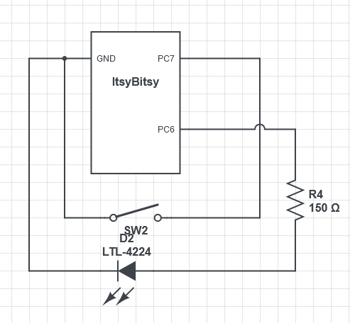

2.1.2

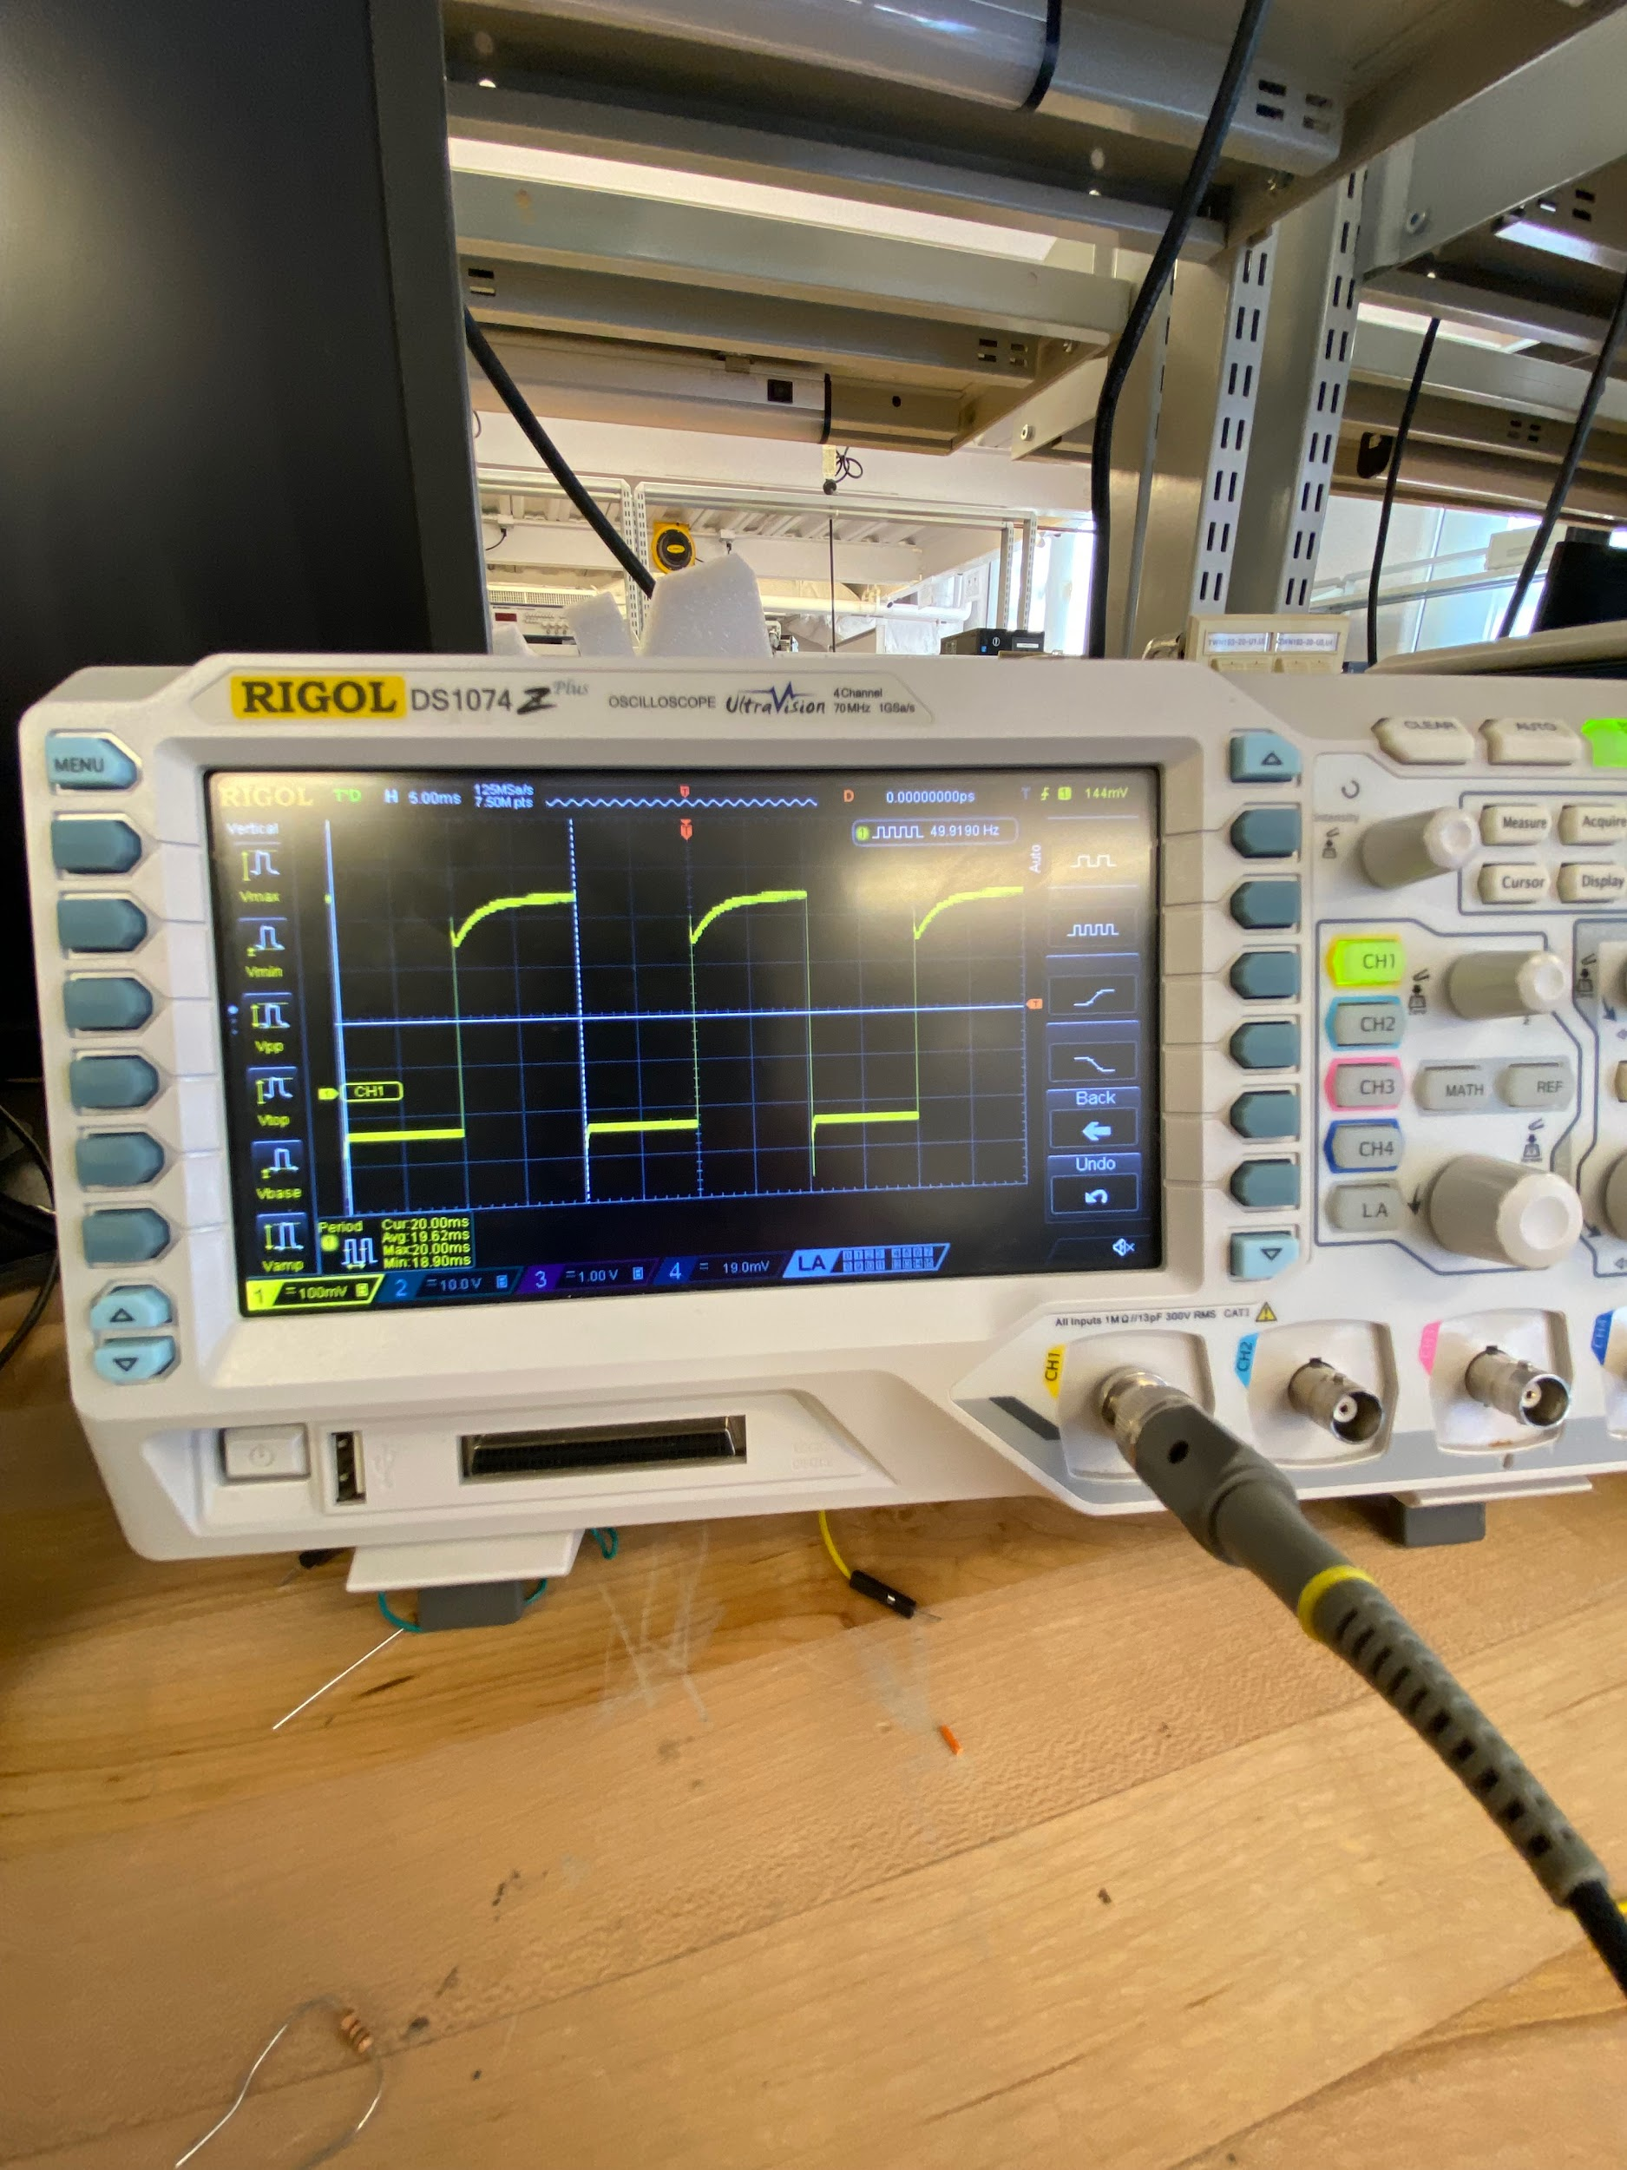

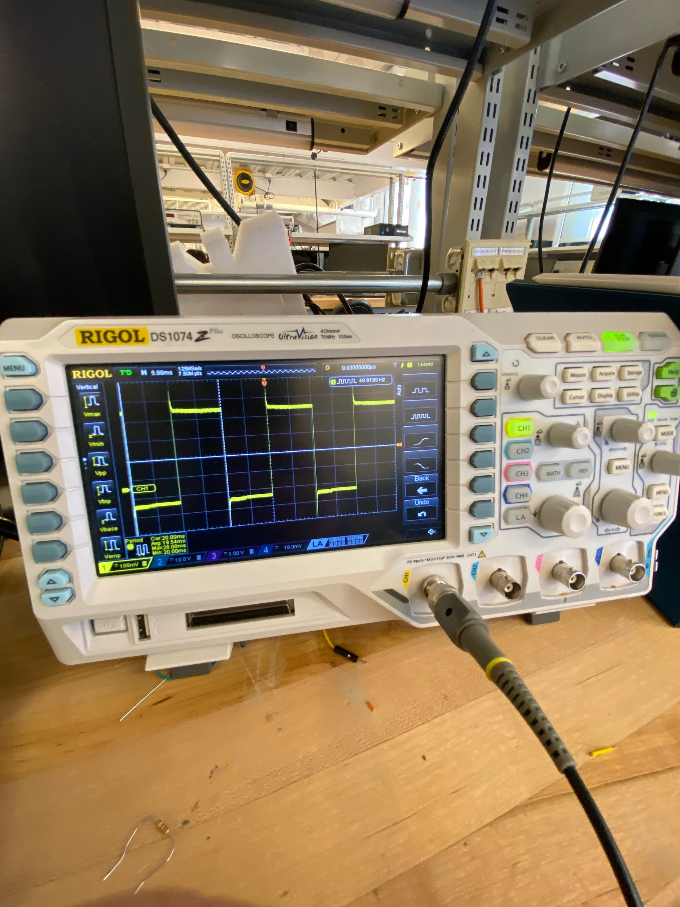

2.1.3

Fastest time: 50ms
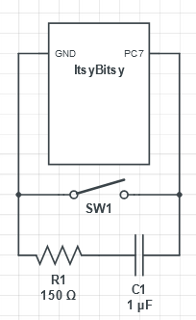

2.1.4EC

Submitted on gradescope

2.2 PHOTOTRANSISTORS

2.2.1

The phototransistor's behavior significantly changes under different light conditions.With more light, more current flows through the phototransistor due to the increase in generated charge carriers. This results in a lower voltage level at the junction between the phototransistor and the resistor. In lower light conditions, less current flows through the phototransistor, leading the voltage level at the junction to be higher.

2.2.2

Video

2.2.3

The ideal resistor for the light being sensitive to waving is 2MΩ. Video
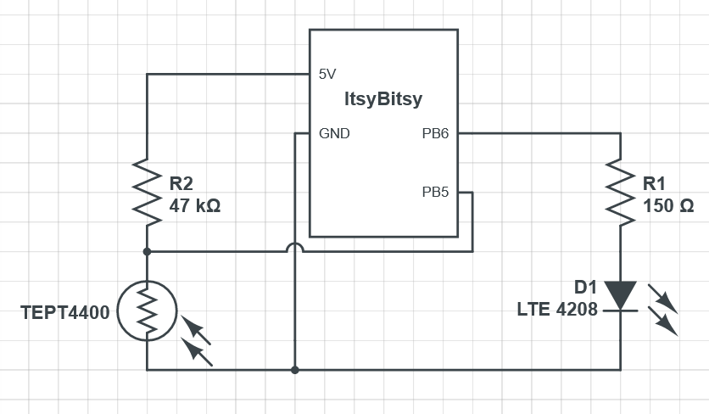

2.3 PHOTOTRANSISTORS

2.3.1

The phototransistor's behavior significantly changes under different light conditions.With more light, more current flows through the phototransistor due to the increase in generated charge carriers. This results in a lower voltage level at the junction between the phototransistor and the resistor. In lower light conditions, less current flows through the phototransistor, leading the voltage le

100 + 22 ohm (trying 126ohm in total)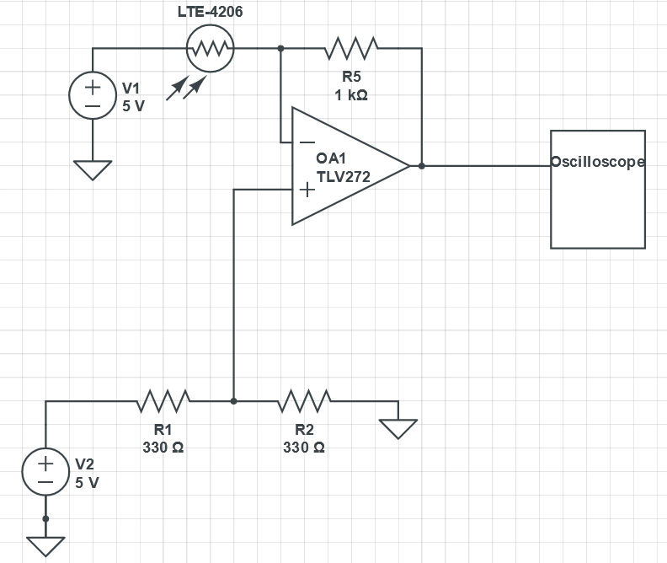

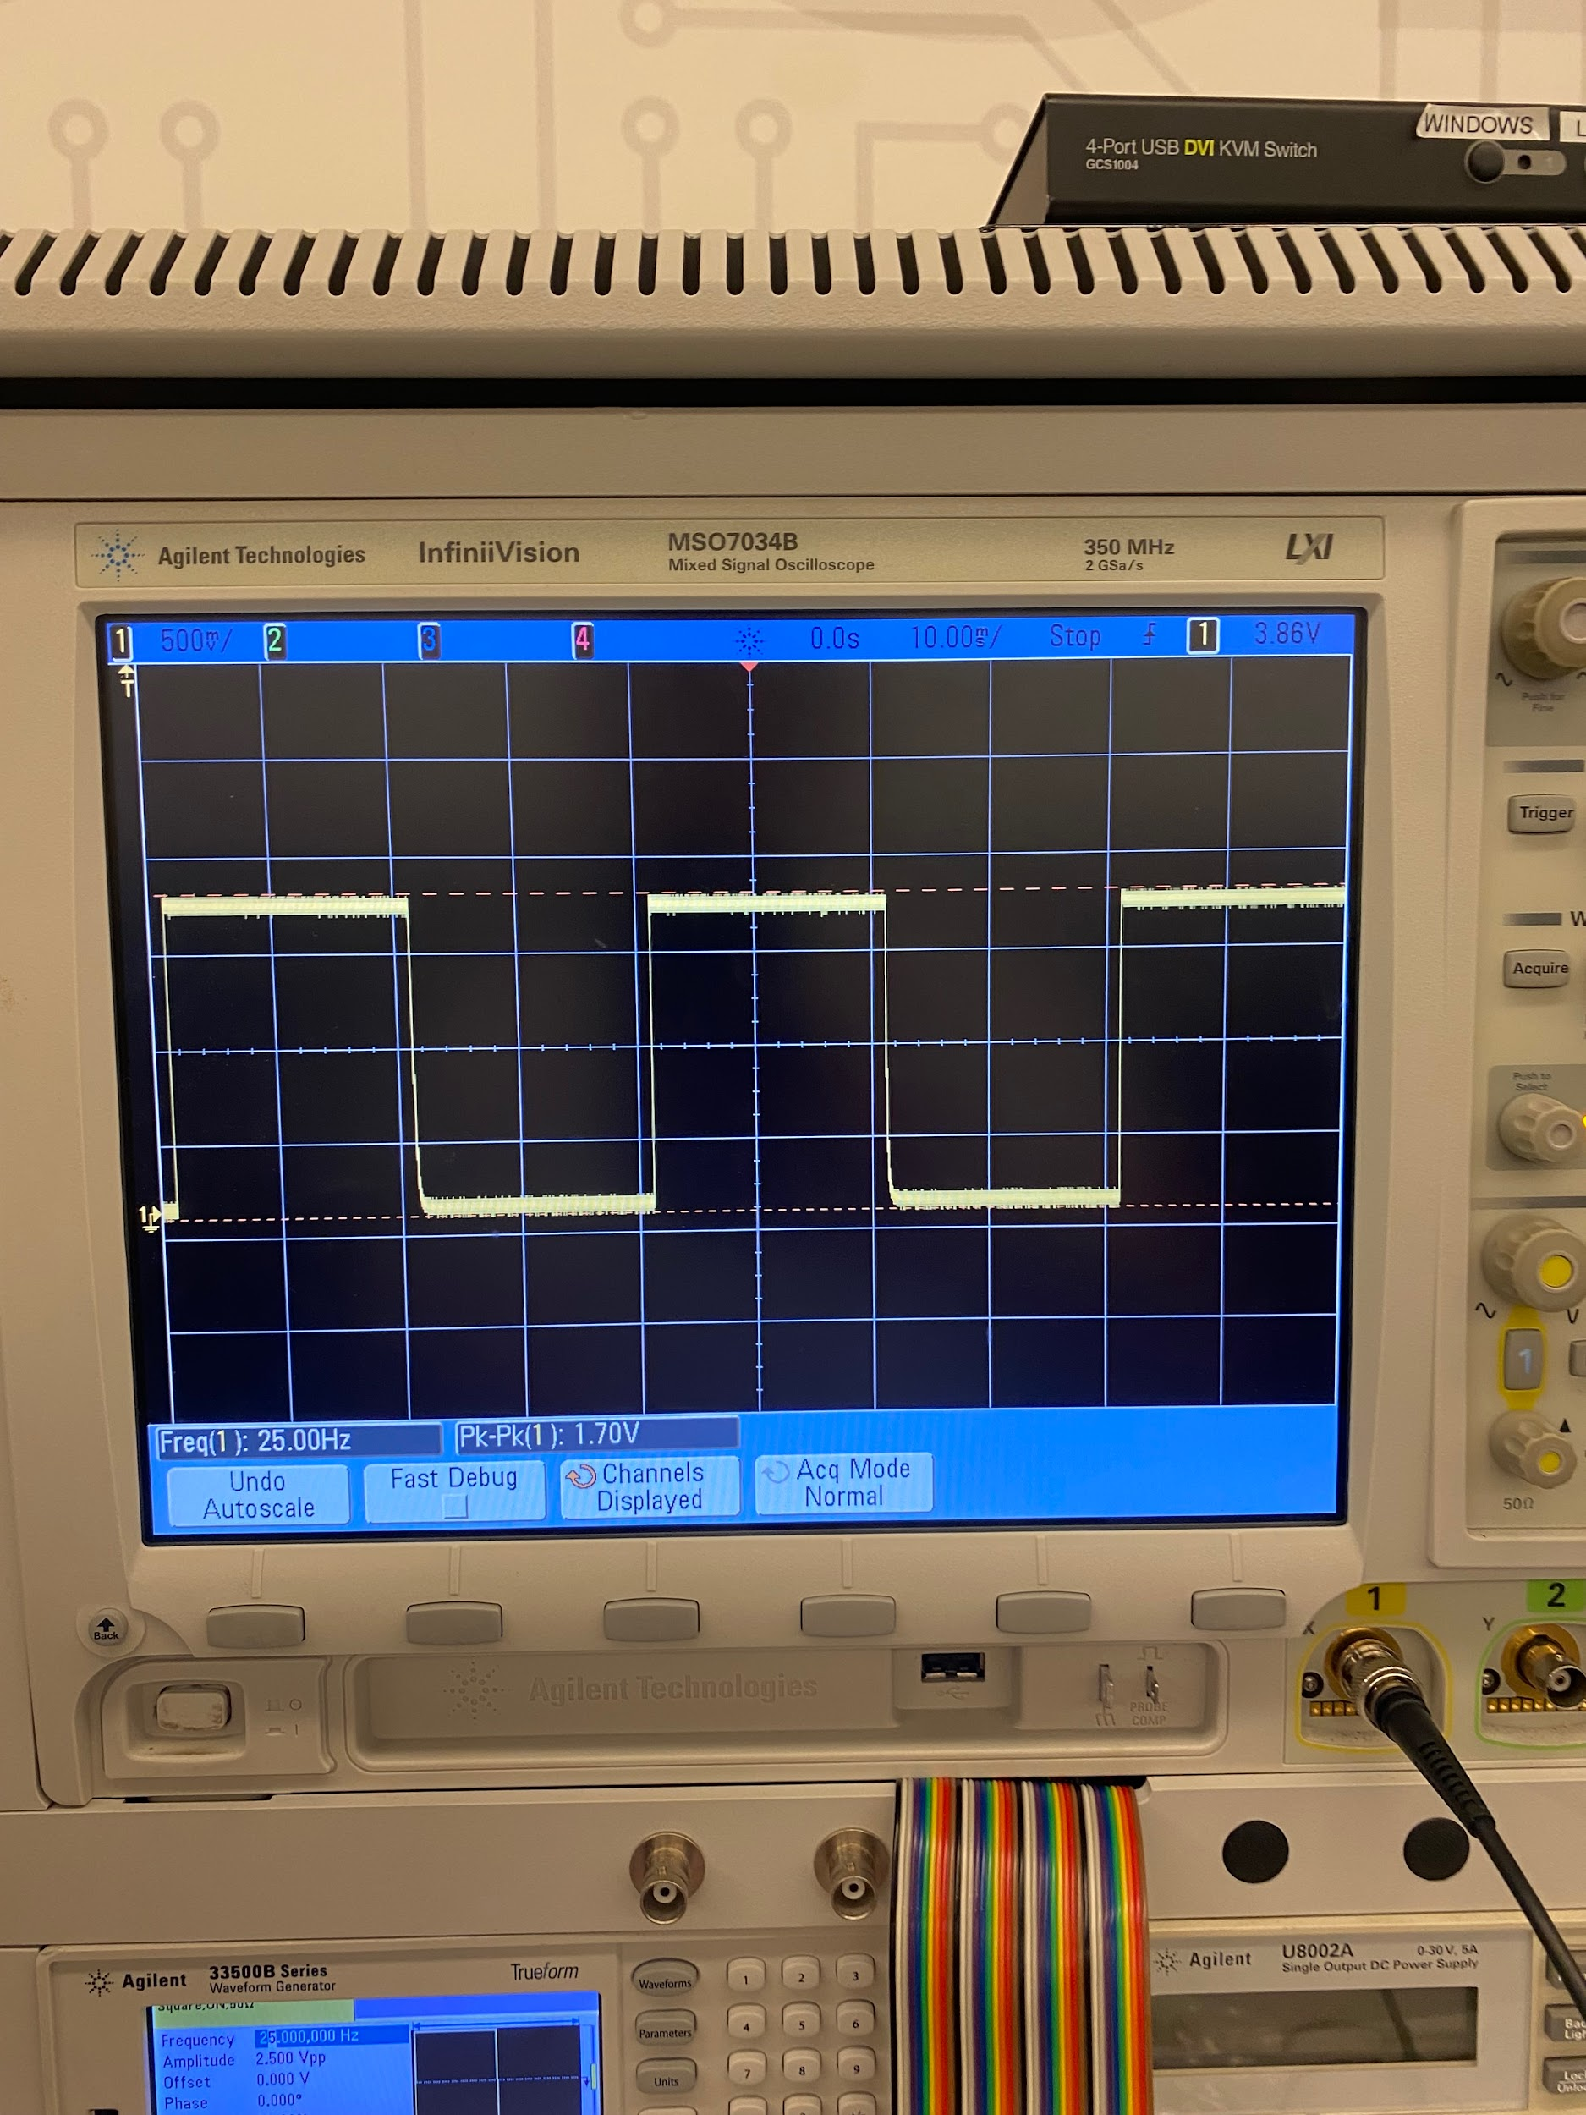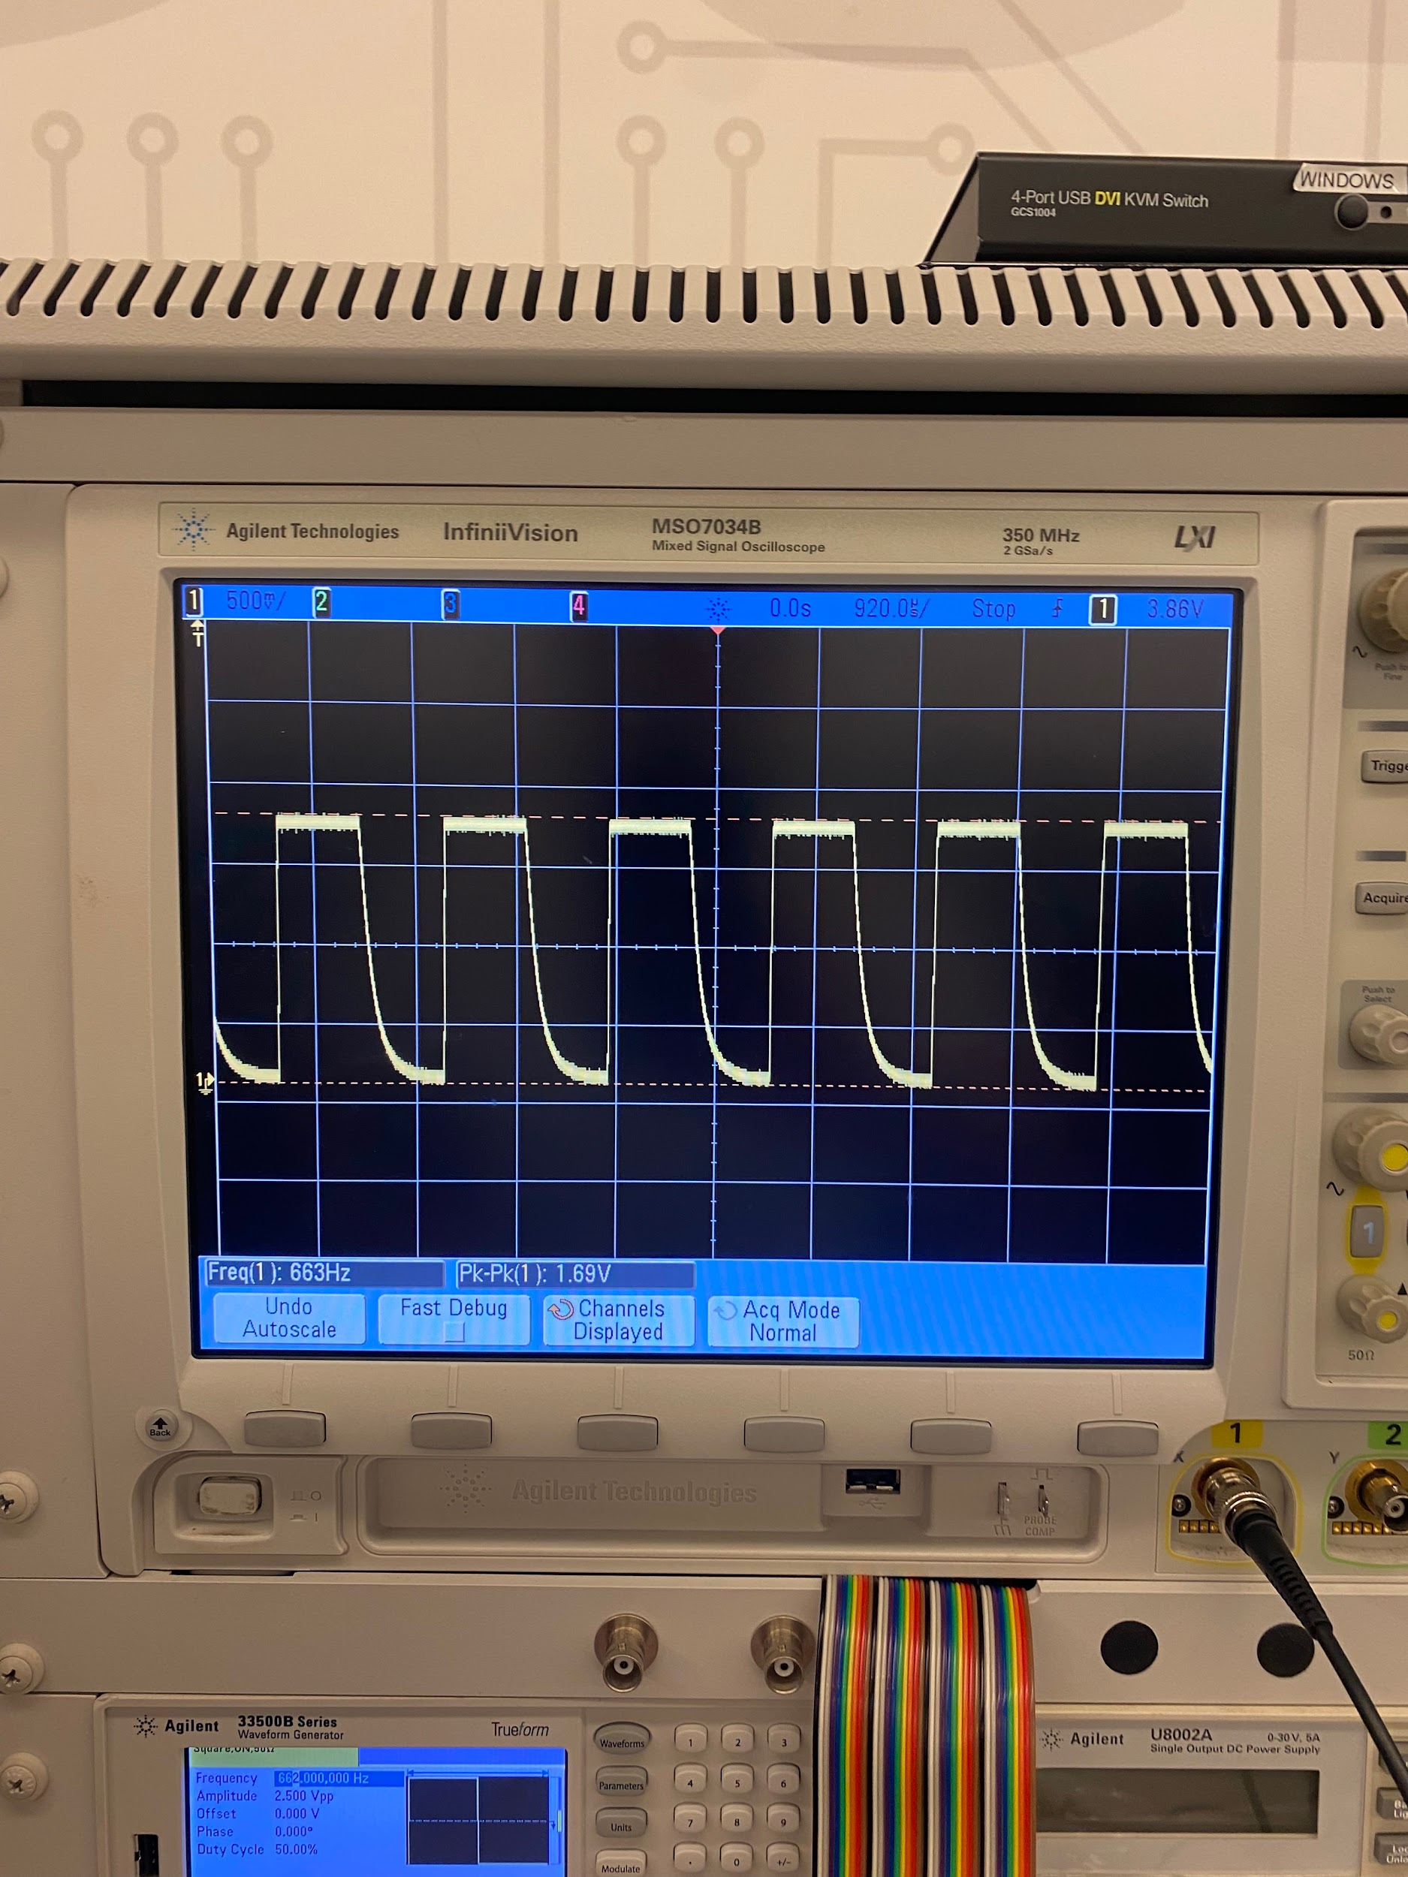

2.3.2 & 2.4.1 and 2.4.2

Did extra credit for 2.4.2 as well
