MEAM 510 - Lab 3 Waldo

1.1
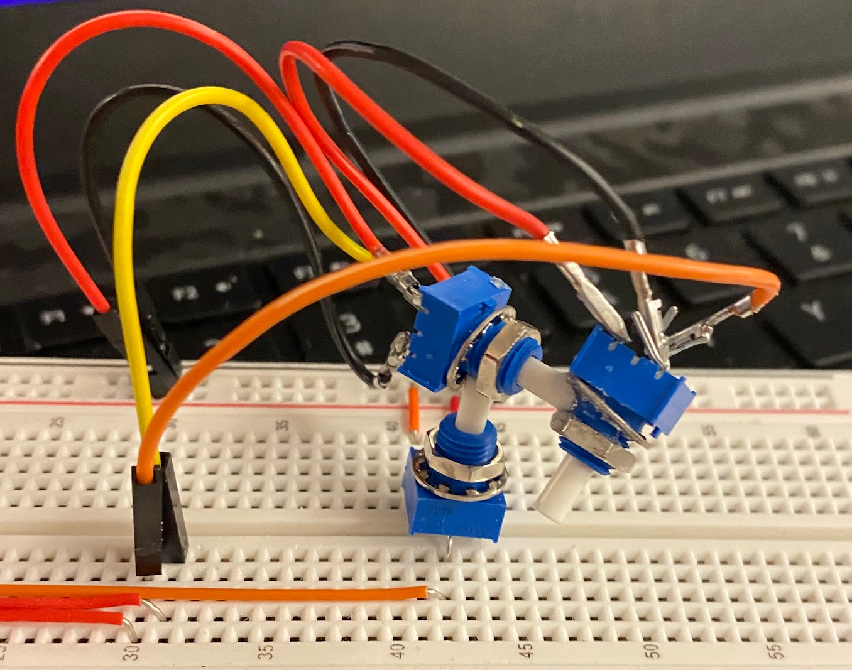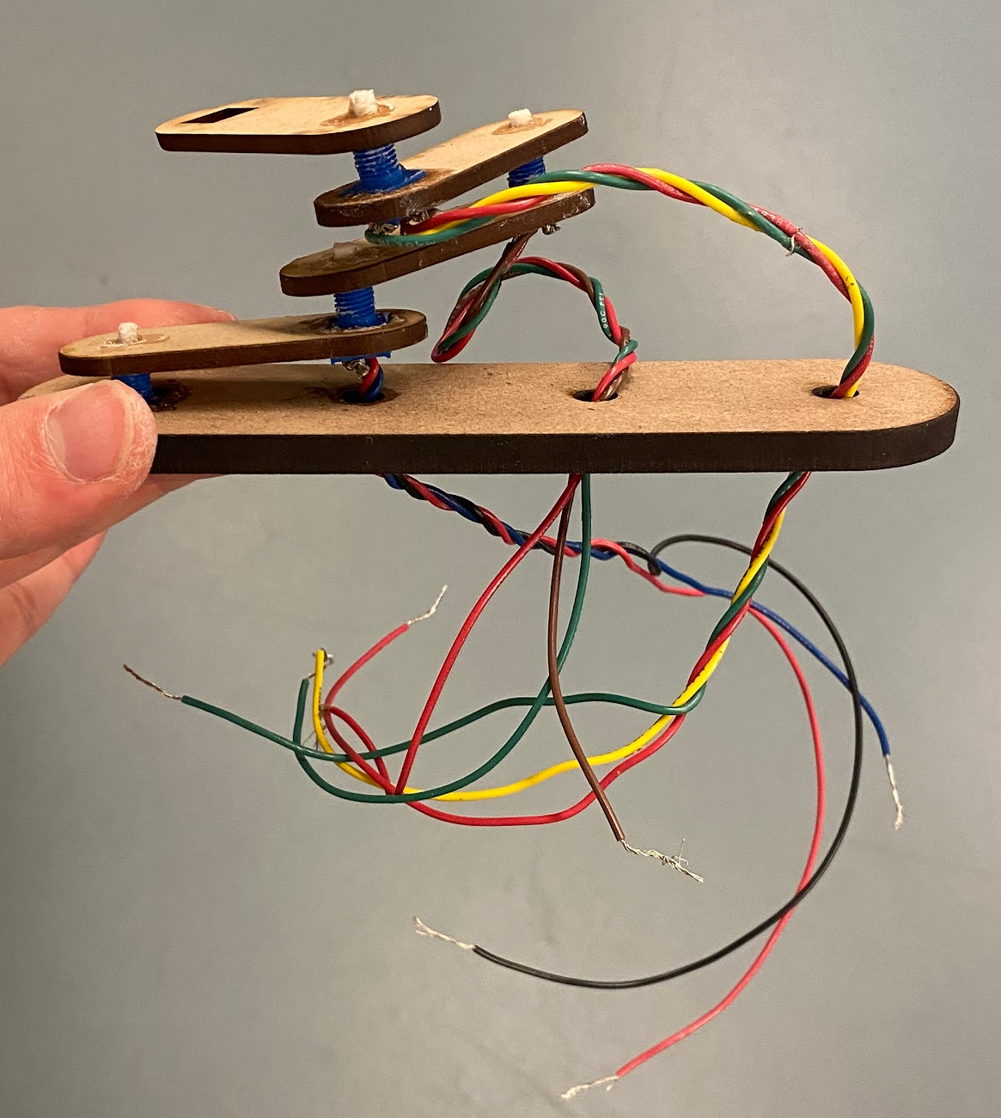
New design Old design

My old design stopped working when I assembled all the components with hot glue. So I switched to a more compact les complex design.
The output would be an upscaled version of the new design. The CAD base is below in 1.3.

1.2

1.3 https://drive.google.com/file/d/1YtdAQQ48BLjwsw9f6bIeYBJ3rqtHzd-y/view?usp=sharing
My device has a sensitivity which goes from 0 to 270° which corresponds to 0 to 1024 in digital. There is minimal noise as long as we proceed slowly whils rotating each potentiometer.
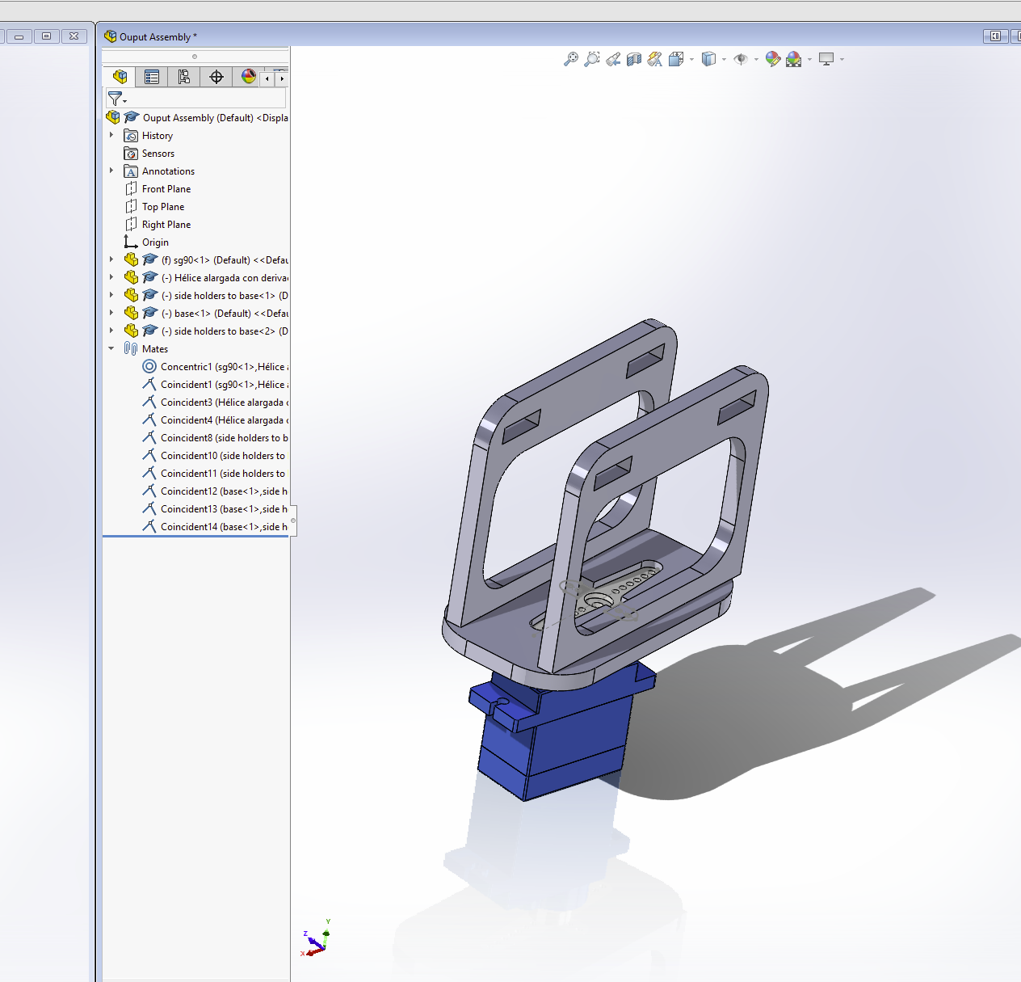

2.1 Finalized hardware design
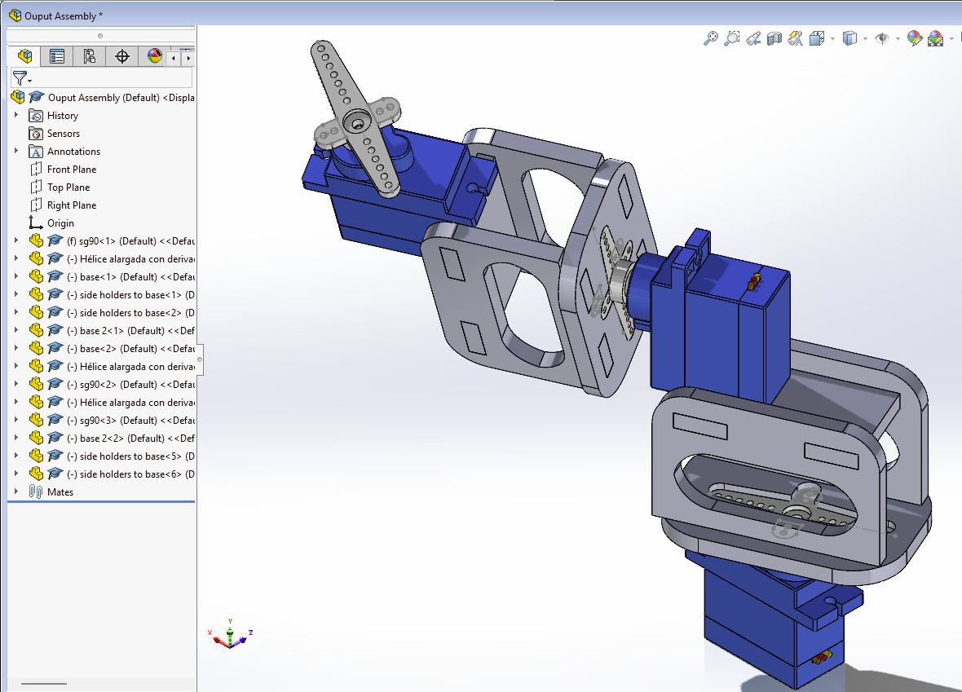
All dimensions are in mm. Rotating the potentiometers in the desired directions will rotate the output system in the same directions. I decided to have the input be simple and the output be at a greater scale because that is usually the objective in control and automation of robots in more complex projects. I worked on getting the sg90 rotator add-ons be a solid press fit to my laser cut parts and then sticky glue them to maximize stability and strength.
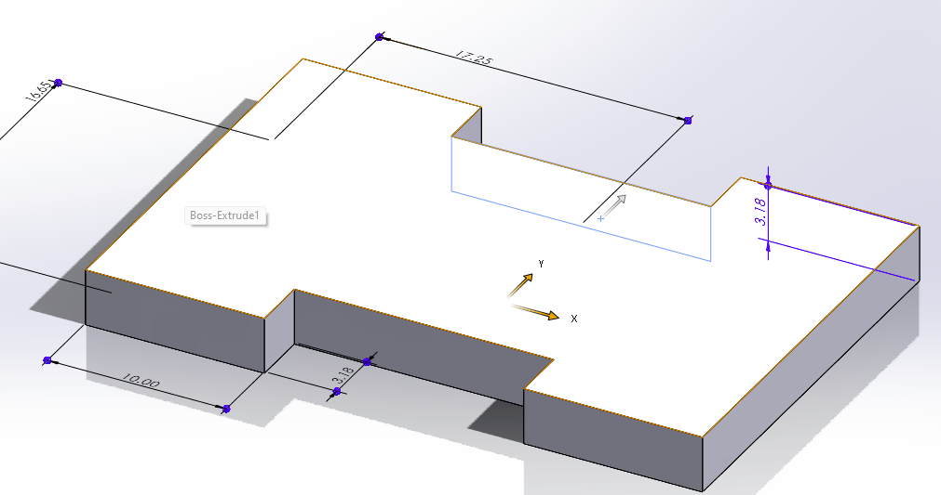

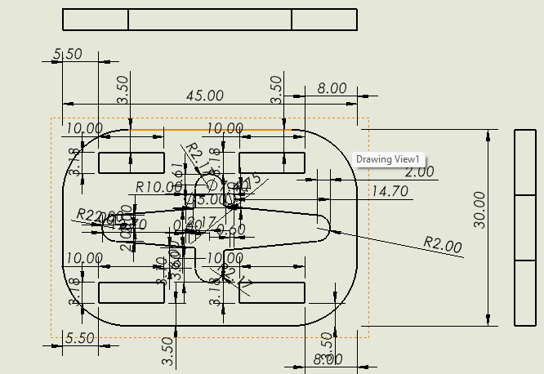
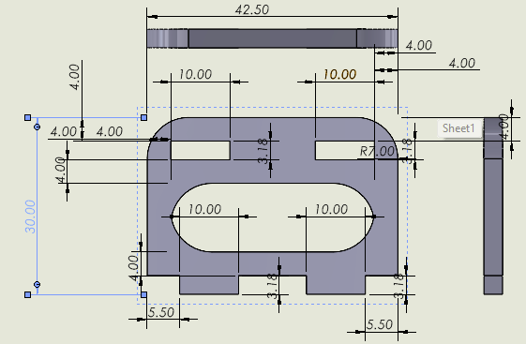
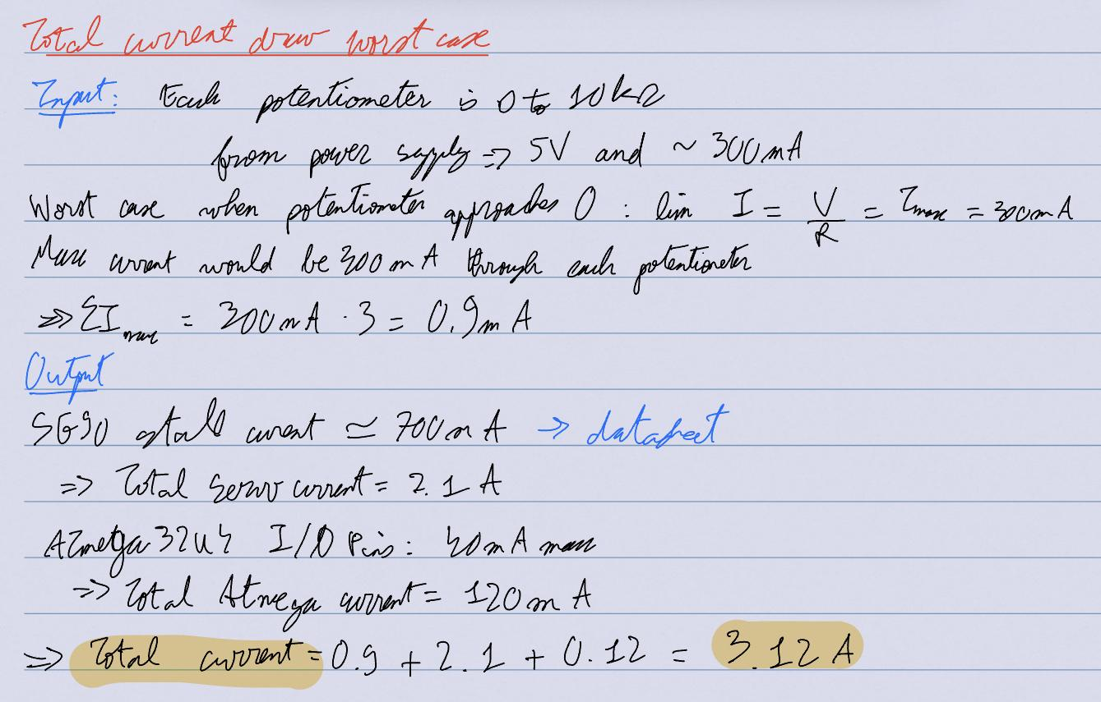
2.2 Hardware fabrication and analysis
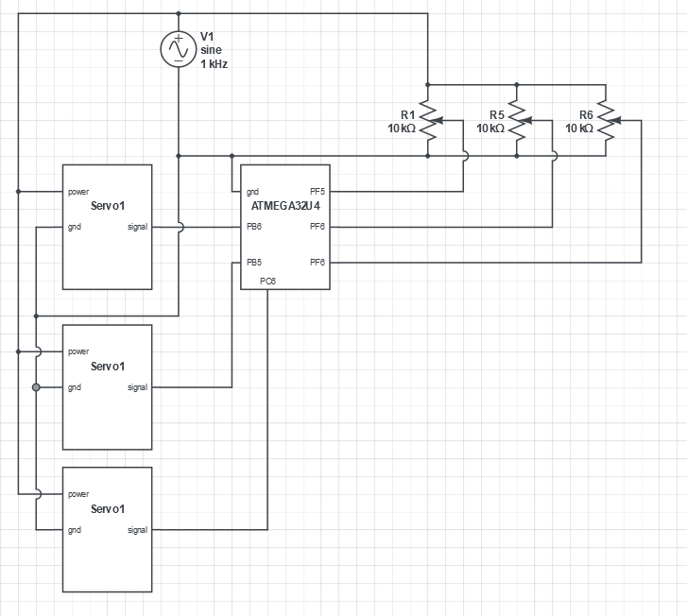

2.3 Software Integration and demonstration
https://drive.google.com/file/d/1-xv7h9_B17bIxuvuVHTwv2cBQcX0DxDl/view?usp=sharing

2.4 Do a dance!
https://drive.google.com/file/d/1vkWpwSOGQDD438eY5zipx4Zc8kn-4fzn/view?usp=sharing

