Lab 4.2: Mobility
Team 23: Zach Rudder, John D’Ambrosio, Cedric Hollande
MEAM 5100
Dr. Yim
11/15/2023



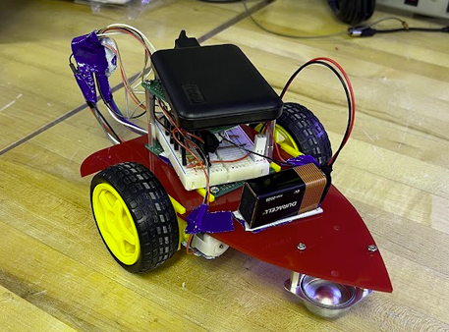
I. Description of Mobile Base Approach
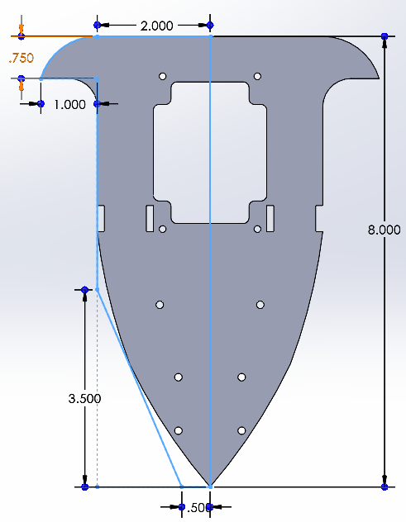
The objective of this lab was to create a WiFi-controlled car that could complete three laps around a course in the fastest possible time. We opted for a mobile base with 2 powered wheels, each one independently controlled by a DC motor and a ball caster in the front. Initially, we were using a third rotary wheel, which we believed would provide stability and directional guidance; however, switching to a ball caster made our design more stable and enhanced the robot’s PID control, steering, and general maneuverability. We went through five different designs, primarily due to how compact we aimed to make the car.
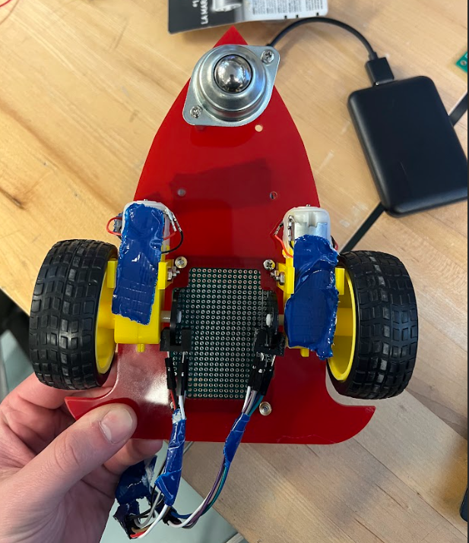
We moved the power bank, circuit, and 9V battery closer to the wheels to ensure stability and prevent the wheels from sticking to the ground. We stacked the power bank directly above the breadboard using a perf board as the platform. Initially, we had a pack of 4 batteries providing 5V; however, we switched to a 9V battery since they did not generate enough power and speed in the robot. For stable connections and to avoid any loose wires, we taped the wires from the motor to the bottoms of the motors and the chassis so they would not break off. Additionally, we soldered some cables, such as the power wires for the motor and the encoder wires. We focused on having a sturdy design with most parts being screwed together to avoid any looseness, which would lead to greater directional instability.

II. Discussion of Performance
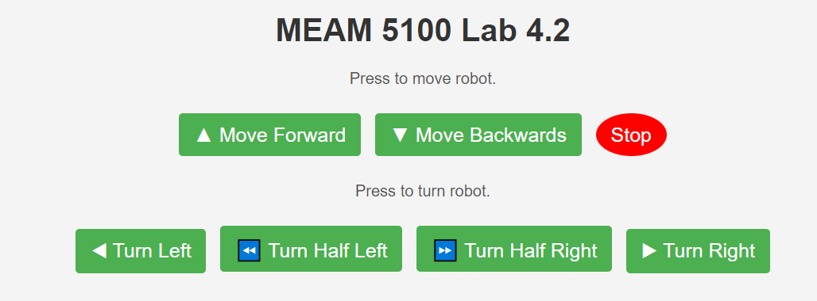
Our robot performed fairly well in the race, although we certainly left room for improvement. Implementing PID control in our race instead of using two sliders proved challenging. Since our motors were imbalanced, with the right slightly weaker than the left, we figured we could achieve better performance with the controller. This proved true for straight-line performance, as our robot stayed incredibly straight on flat ground, only slightly veering on the wooden test track. The drawback to this, however, was that we could not implement real-time turning with the controller running. So, whenever our robot veers too far to the left or right, we would have to stop it, make a slight turn, and have it continue straight. We also had to fully stop the robot when making full left and right turns. This, in combination with WiFI delays, made it very difficult to achieve a high speed. Our webpage interface can be seen below. Our first test run was completed in 2:11. With some better timing on our turning button presses; we managed to get that time down to 1:44. Going forward, we would change the drive train, as we believe our setup lacked some stability and probably influenced the drifting of our robot. Additionally, we would like to add a servo to the front of the robot so that it can turn while moving with the controller still active, similar to how most RWD cars work. In terms of the chassis, we would make it more rounded and enclose the wheels so that the robot is able to bounce off of the walls instead of getting stuck when it makes slight contact with them.
Videos for 4.2.2.1: Robot going straight for 1m+ & Robot going straight after disruption
III. Circuit Diagram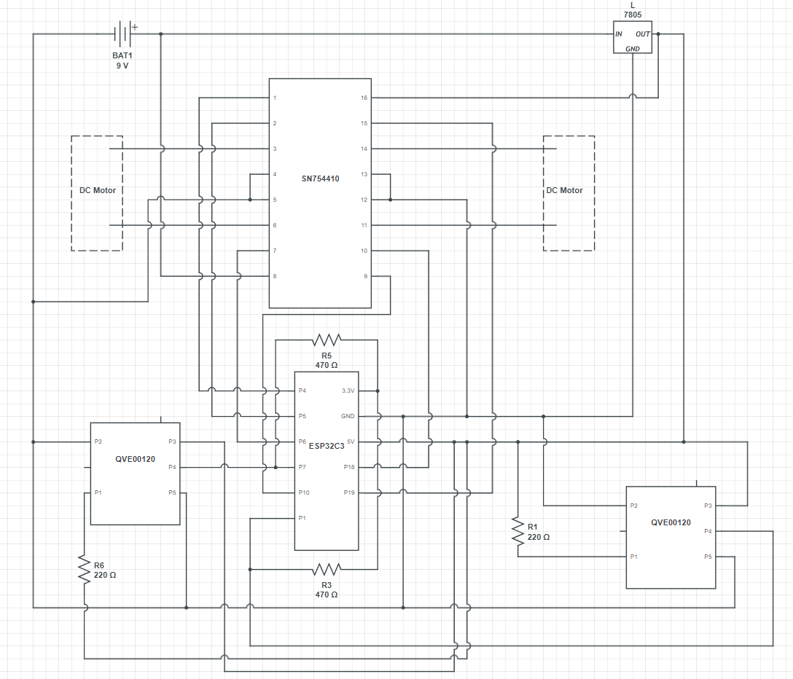
Our code is submitted separately on Gradescope. It is the same for 4.2.2 and 4.2.2.1

IV. Bill of Materials
- One Duracell 9V battery
- One ESP32 C3
- Two 220Ω resistors
- Two 470Ω resistors
- L7805 voltage regulator
- Two QVE00120 optical encoders
- One SN754410 motor driver
- One half breadboard
- Two perf boards
- Two yellow DC motors
- One ball caster wheel
- Two plastic yellow wheels
- One acrylic chassis
- One Miady power bank

V. Division of Labor
All members must have experience in every single part of the project. This involved individually working on our assigned roles at the beginning of the lab and then reviewing the improvements as a team, explaining out loud why we took certain decisions to see if they made sense, and also reflecting together to come up with even better solutions, With that in mind, we assigned main roles to the different components of the robot. Cedric focused more on the CAD design, John worked mostly on setting up the encoders and creating the PID controller, and Zach focused on the HTML interface to control the car. After the initial designs of each part, we all came together to improve and optimize our robot. This involved many trial runs to fix weight distribution, wire connections, tuning parameters, and improving the webpage functions.

